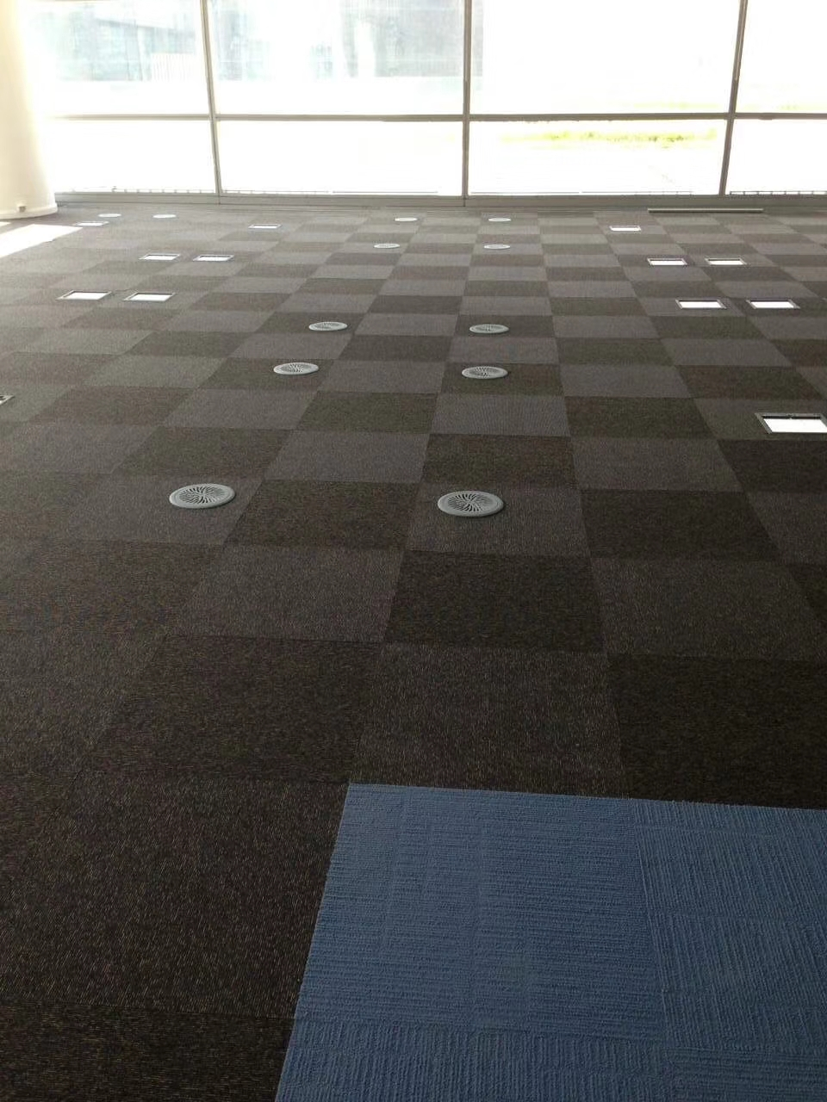

Bare Finish Steel Raised Floor

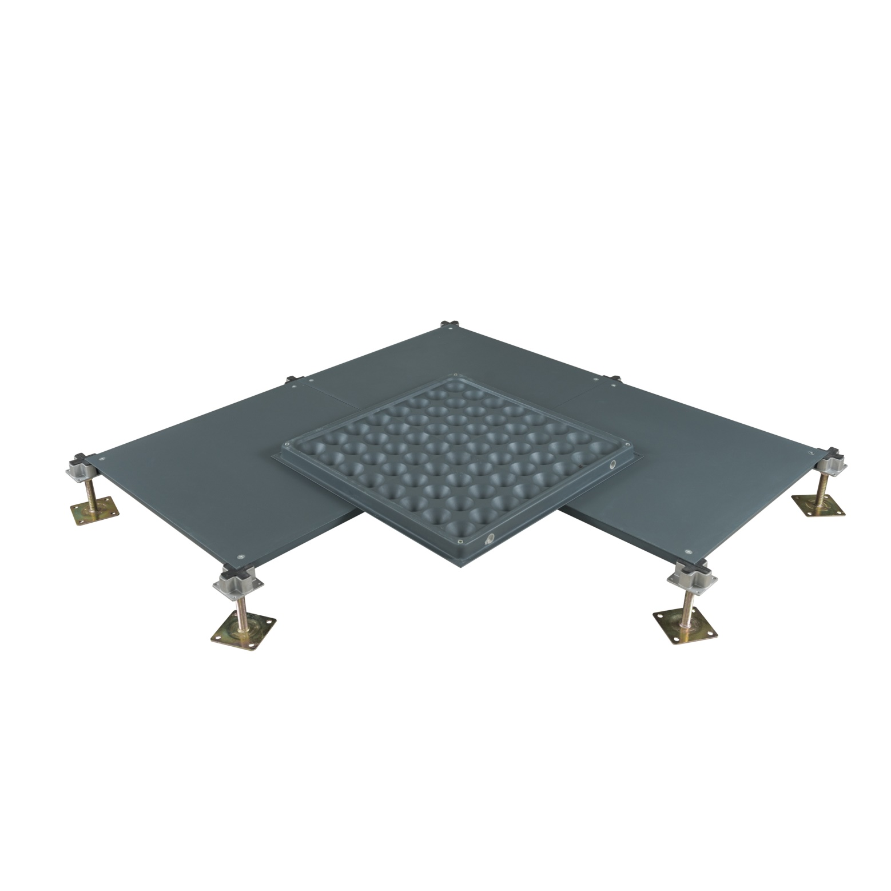

Abeite Bare Finish Steel Raised Floor is a new patent “cross strengthening rib”
and “concave rib structure”, which can enhance 10-30% more loading capacity. From
the selection of materials, procurement, production, packaging, are following with
the Chinese and PSA MOB PS/SPU、DIN EN 12825 specifications.

Construction:
Bare Steel Raised Floor is manufactured from cold-rolled steel resistance welded, lightweight
cement infilled. This raised floor system is composed of panels, pedestals, anti-vibration
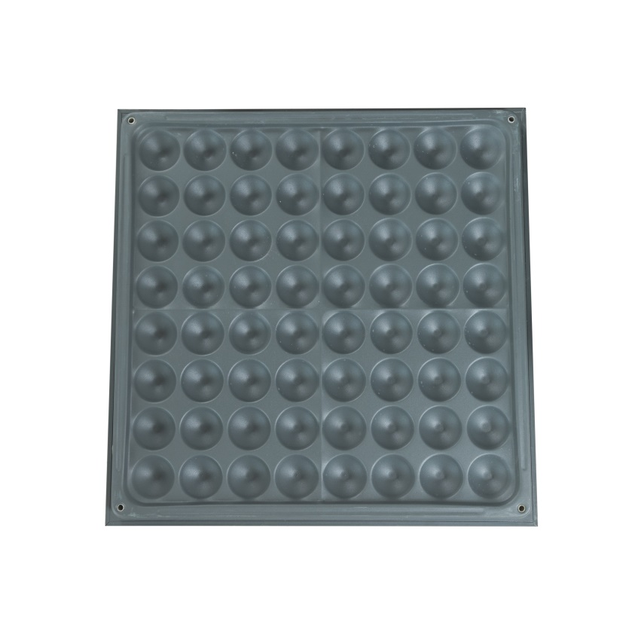
gasket and screws. The panel is placed on top of the pedestals with an anti-vibration gasket
and then locked in place with the screws in the corner-lock holes.

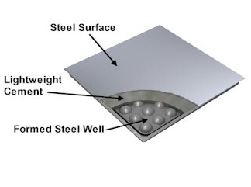

Type: | FS662-2000
Finished Floor Height: | 50-1000mm
Panel Size: | 500*500*28mm、600*600*33mm、610*610mm
Edge Trim Type: | Bent edge/Cut edge
Trunking | Available
Grommet Hole | Available
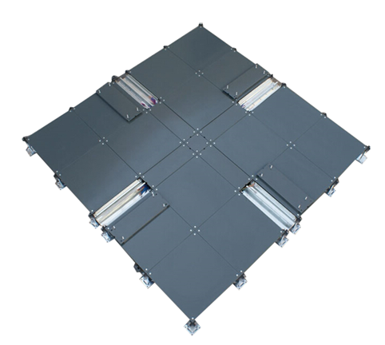  Installation: | Without or With Stringer System
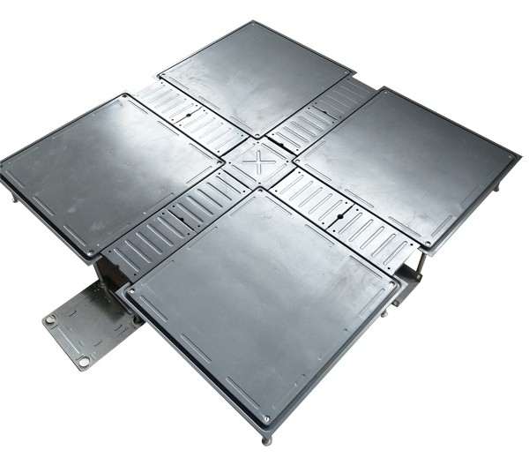

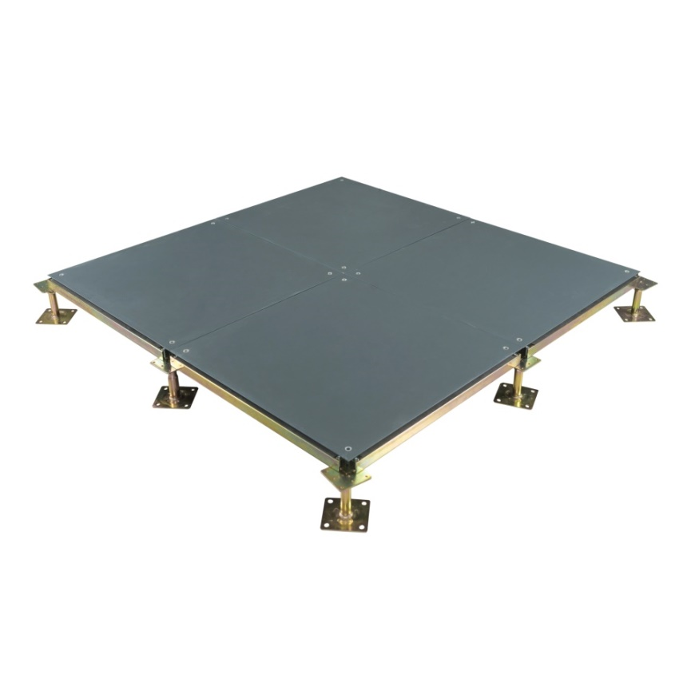
Intelligent Network Raised Floor Low Profile Raised Floor

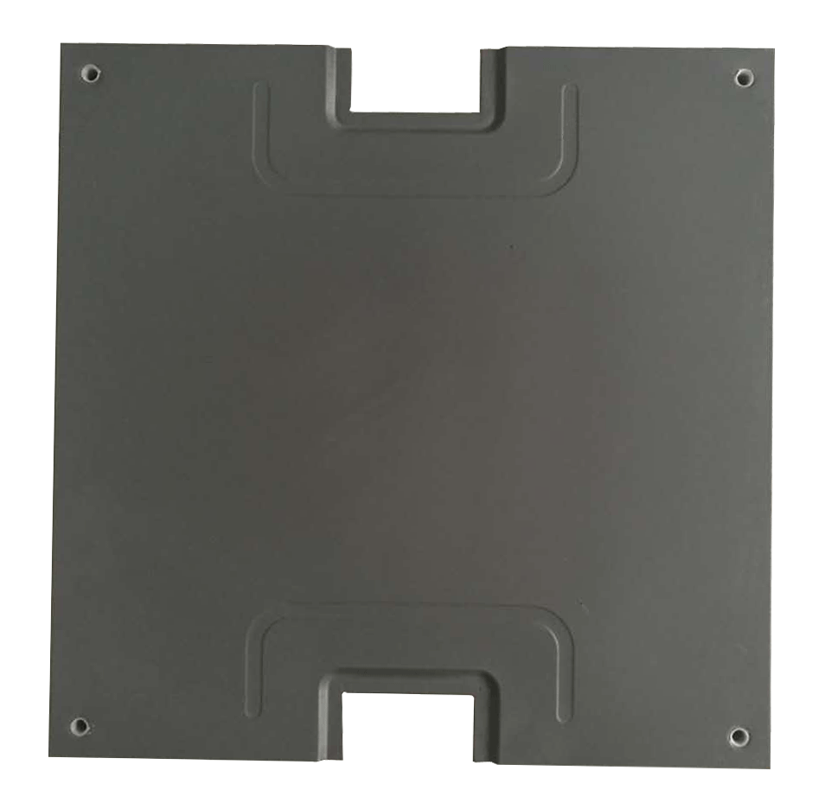

Cutout Bare Panel Bolted Stringer System

Characteristics:
- Epoxy paint for lifetime protection;
- Tolerance of panel size is 0-0.40mm; Tolerance of panel thickness is ±0.30mm;
Un-flatness is ≤0.60mm;
- The load performance is strong;
- Class A flame spread & smoke-developed index
- OEM is available;

Applications:
Office building, intelligent office environment, meeting room, commercial and industrial bureau,
government, places that have requirements of dust-proof and water-proof, fields with requirements,
usually used with square carpet.

Specification:

Type | Size | Concertrated Load Defleation≤2.5mm |  |  | Uniform Load | Ultimate Load | System Resistance
 | mm | LBS | KN | KG | KN/㎡ | KN | Ω
FS662 | 600*600 (500*500/ 610*610 is optional) | 662 | 2.95 | 300 | 12.50 | 8.85 | 1.0x10⁶-1.0x10⁹
FS800 |  | 800 | 3.56 | 363 | 16.10 | 10.68
FS1000 |  | 1000 | 4.45 | 454 | 23.00 | 13.35
FS1250 |  | 1250 | 5.56 | 567 | 33.00 | 16.68
FS1500 |  | 1500 | 6.67 | 680 | 34.50 | 20.02
FS2000 |  | 2000 | 8.90 | 906 | 46.00 | 26.70

Understructures:
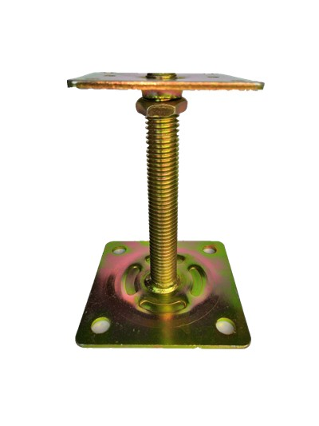
Product name: | Pedestal
Type: | Flat Head
Height: | FFH50-600mm
Top plate: | 75*75*3.0mm
Base plate:: | 95*95*2.0mm
Threaded rod: | M18/20
Surface: | Cold galvanizing  Hot galvanizing  Powder coated
Gasket: | Without

Product name: | Pedestal
Type: | Cross Head (Aluminum and steel is optional)
Height: | FFH50-600mm
Top plate: | 70*70mm
Base plate:: | 95*95*3.0mm
Threaded rod: | M18/20
Surface: | Cold galvanizing  Hot galvanizing  Powder coated
Gasket: | With

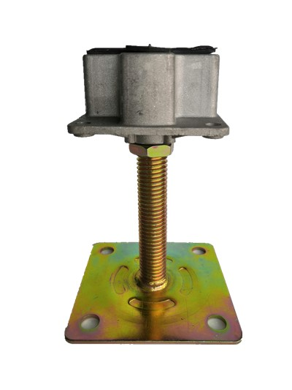

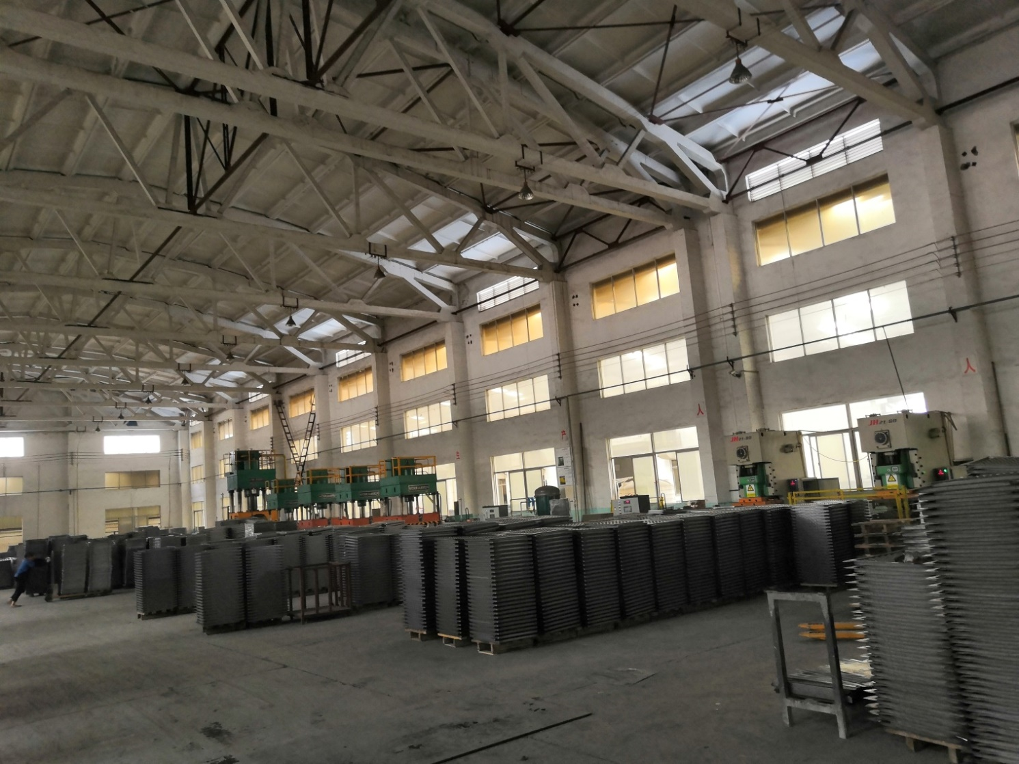

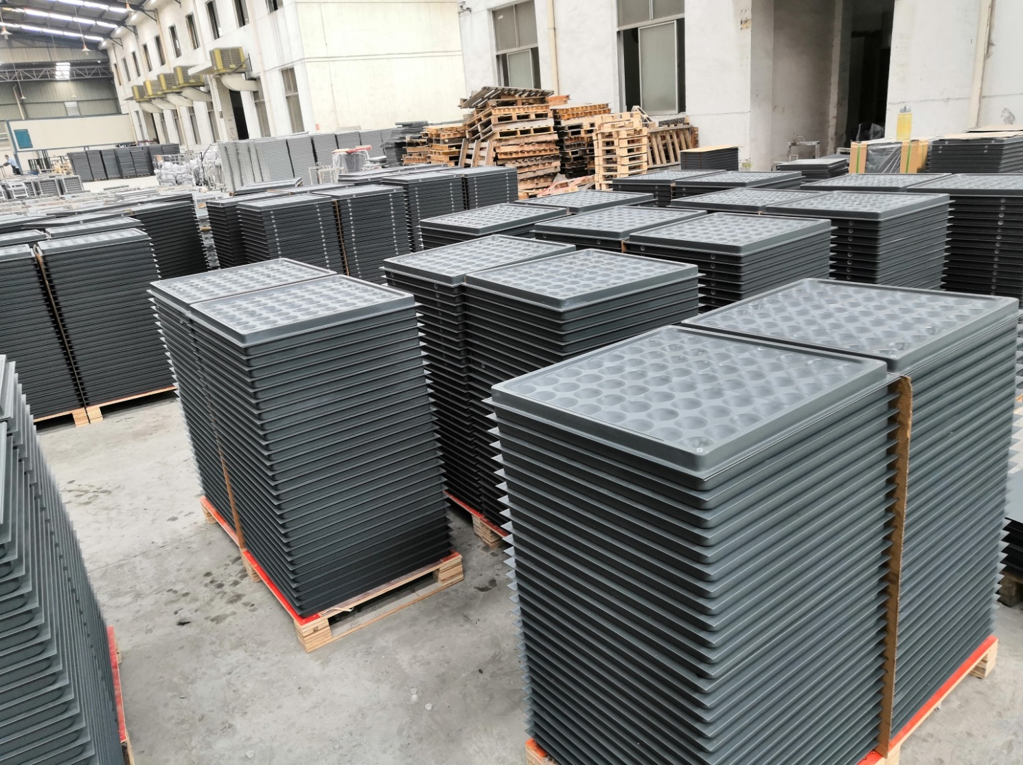

Changzhou Abeite Computer Room Equipment Co.,Ltd
Add: No. 108, Chaoyang Village, Hengshanqiao Town, Wujin District,
Changzhou City, Jiangsu Province，China
Tel: +86(519)86056270
Fax: +86(519)86056270
E-mail: info@abeiteraisedfloor.com
Web: www.abeiteraisedfloor.com

