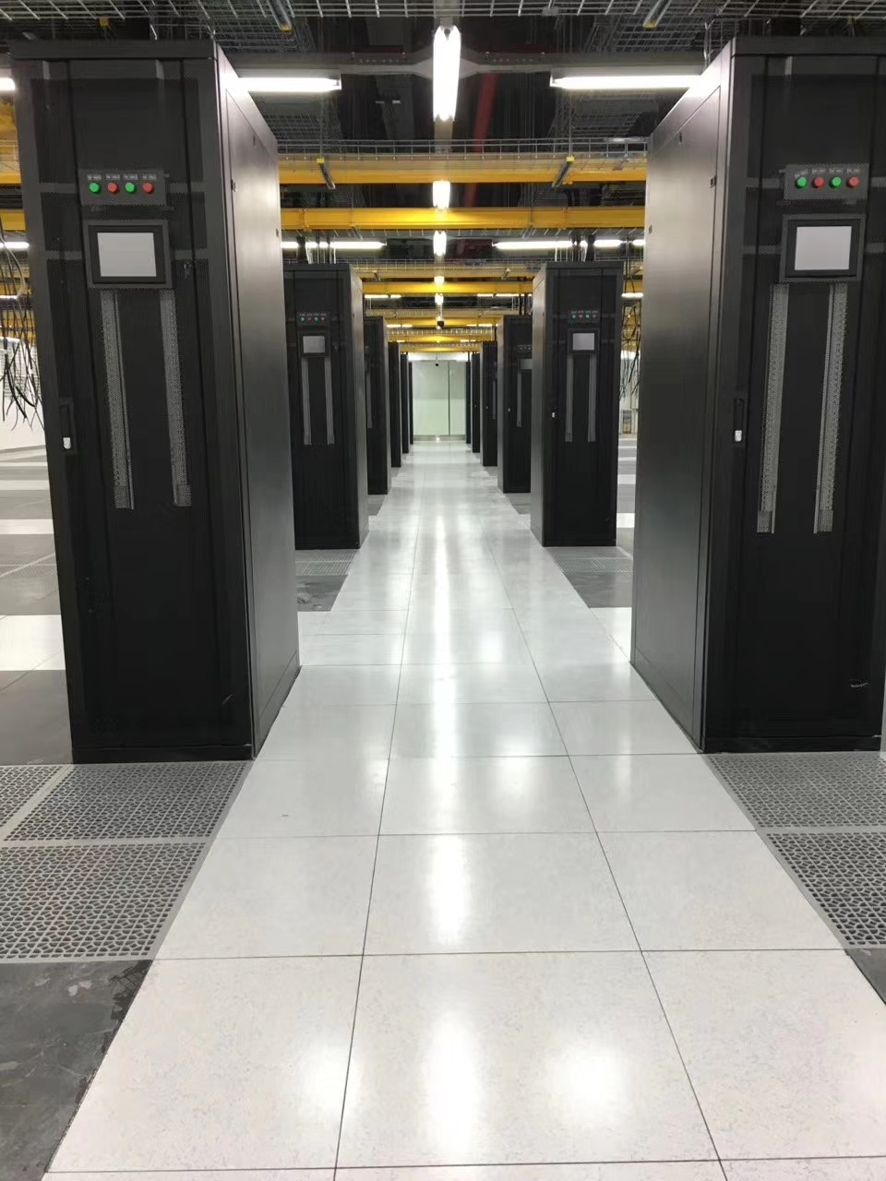

Ceramic Finish Raised Floor

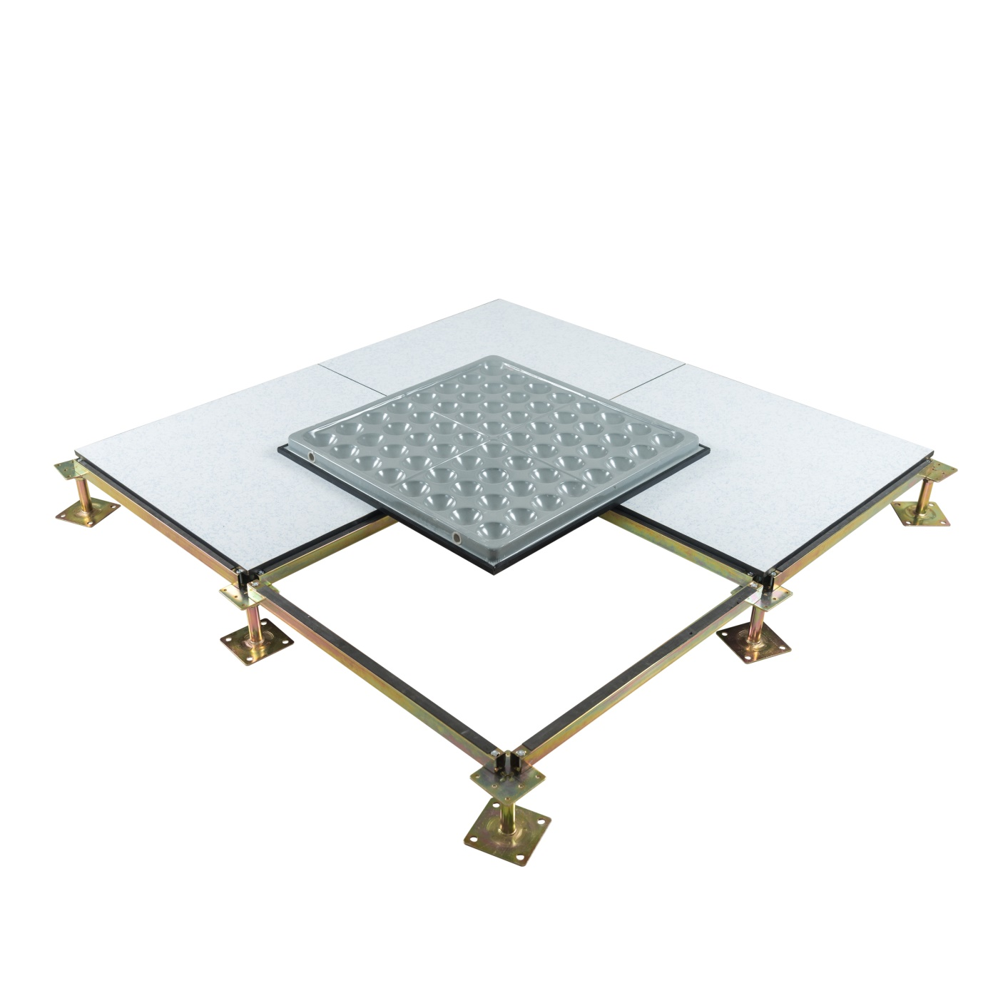

Abeite Ceramic Finish Raised Floor is based on cold-rolled steel, high-density
calcium sulfate panel or chipboard. The bottom finished with galvanized steel sheet or
aluminum foil, etc covering. From the selection of materials, procurement, production,
packaging, are in accordance with the Chinese and PSA MOB PS/SPU、DIN EN 12825
specifications.

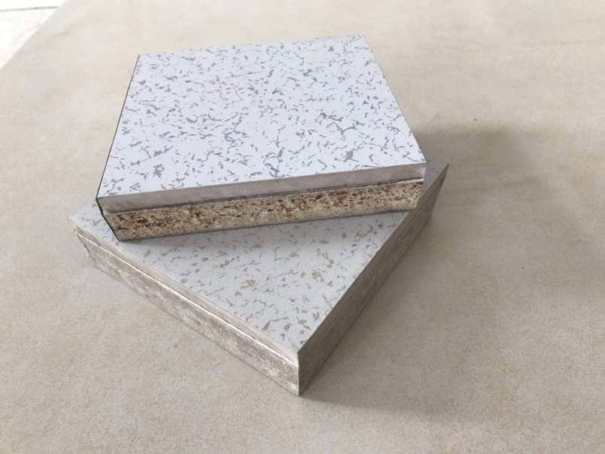
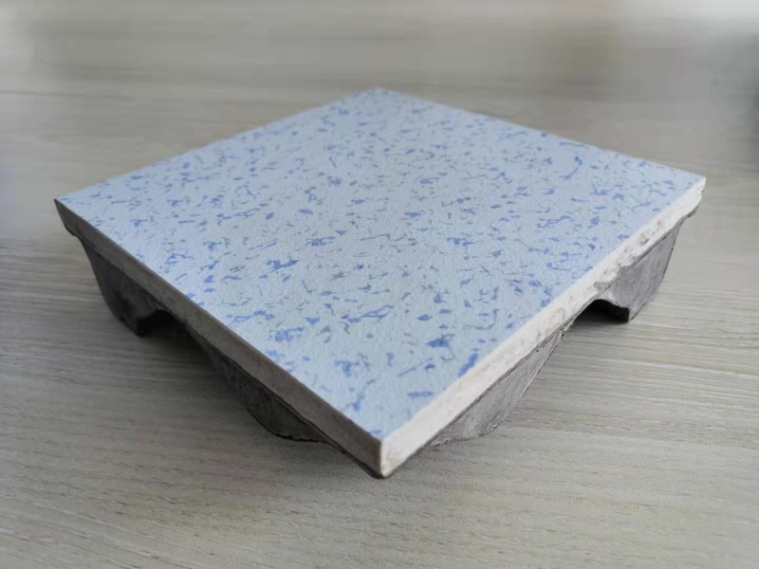

Type: | FS662-1500
Finished Floor Height: | 70-2000mm
Panel Size: | 600*600mm、800*800mm and special size
Ceramic Thickness: | 10/12mm
Ceramic Type: | Normal ceramic and Anti-static ceramic

Characteristics:
1、Stable electrostatic performance, Class A fire, sound insulation, dust and dirt
resistance, chemical corrosion resistance；
2、Strong surface wear resistance, the hardness of 7 degrees Mohs, easy to clean；
3、No deformation, no dust, strong carrying capacity, combined with ceramic
characteristics, anti-aging, the service life of more than 60 years；
4、Variety of colors, including pure white, wood grain, etc., beautifully paved,
decorative；
5、OEM is available;
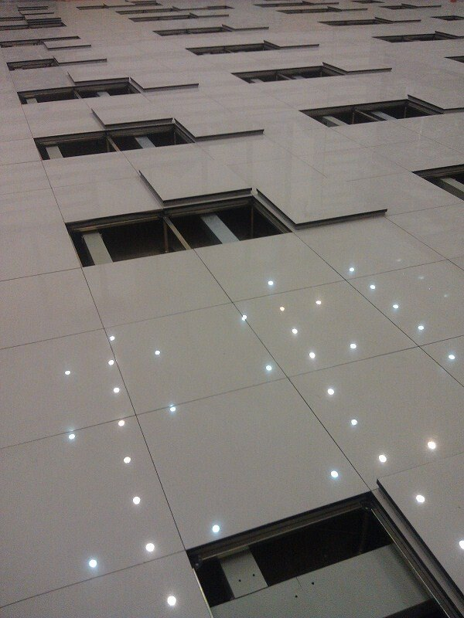
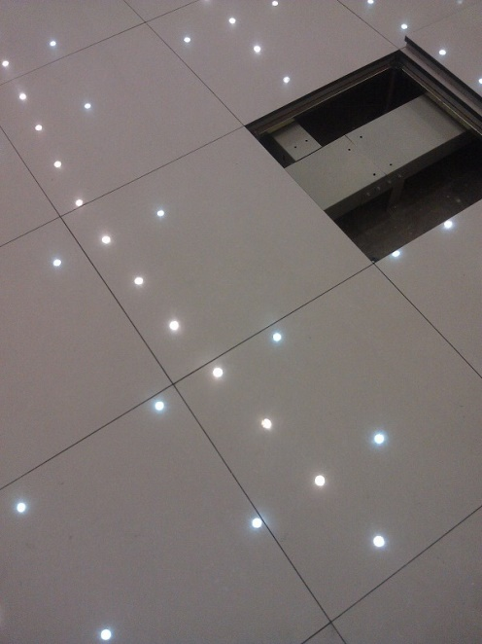

Applications:
Data Centers、Commercial Buildings、Educational Facilities、Clean Rooms、
Control Rooms、Libraries and places where require anti-static environment
or have many wires.

Specification:

Type | Size | Concertrated Load Defleation≤2.5mm |  |  | Uniform Load | Ultimate Load | System Resistance
 | mm | LBS | KN | KG | KN/㎡ | KN | Ω
FS662 | 600*600 | 662 | 2.95 | 300 | 12.50 | 8.85 | 1.0x10⁶-1.0x10⁹
FS800 |  | 800 | 3.56 | 363 | 16.10 | 10.68
FS1000 |  | 1000 | 4.45 | 454 | 23.00 | 13.35
FS1250 |  | 1250 | 5.56 | 567 | 33.00 | 16.68
FS1500 |  | 1500 | 6.67 | 680 | 34.50 | 20.02
FS2000 |  | 2000 | 8.90 | 906 | 46.00 | 26.70

Ceramic Color
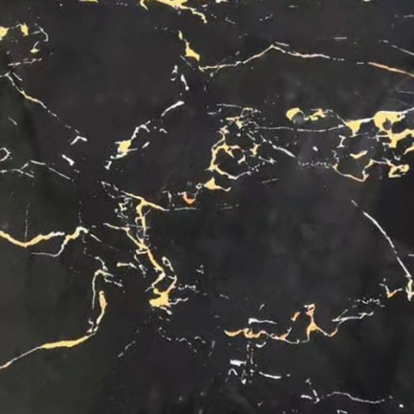
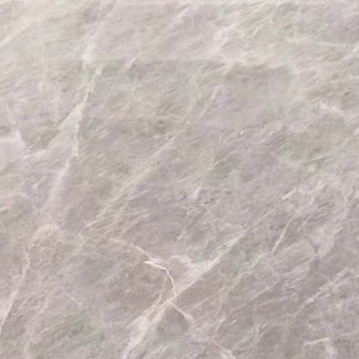
.

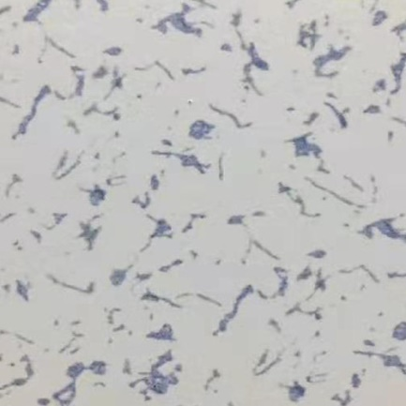
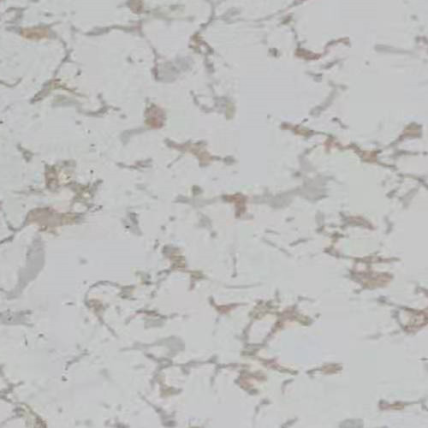

Light gray Gray Heavy gray

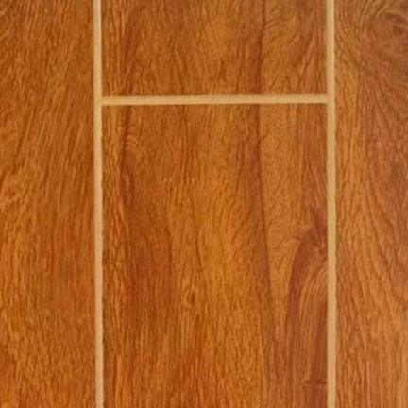
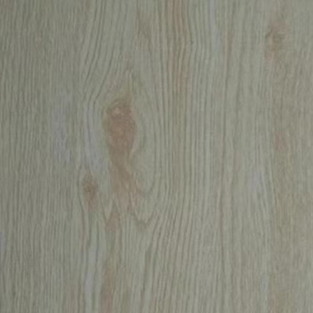
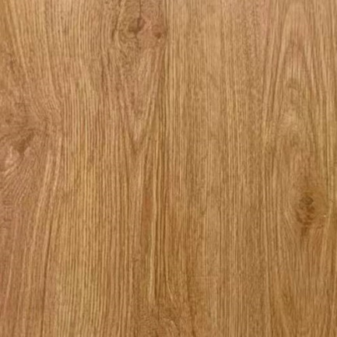

Changzhou Abeite Computer Room Equipment Co.,Ltd
Add: No. 108, Chaoyang Village, Hengshanqiao Town, Wujin District,
Changzhou City, Jiangsu Province，China
Tel: +86(519)86056270
Fax: +86(519)86056270
E-mail: info@abeiteraisedfloor.com
Web: www. abeiteraisedfloor.com

