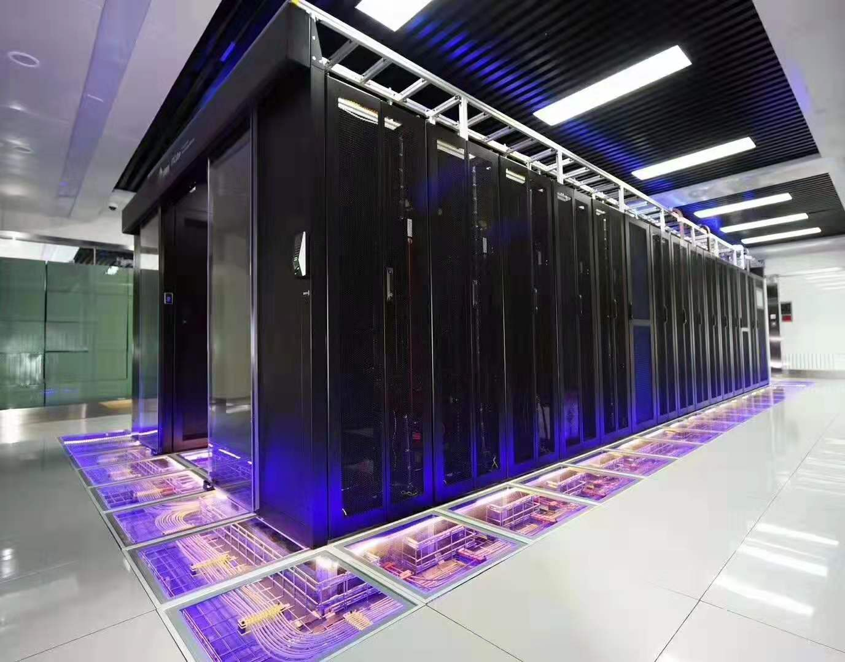

Glass Viewing Raised Floor

Abeite Glass Viewing Raised Floor types fall into two categories: Tempered
Clear Glass and Tempered Laminated Glass. Glass panel can in combination with
steel raised floor, calcium sulfate raised floor, wood core raised floor and aluminum
raised floor.
The glass floor is not the simple tempered glass floor, but the world's leading
aviation special craft glass and aluminum alloy grinding tools. The rigidity and
toughness of the floor itself are the ultimate, and it is the safest transparent glass floor.
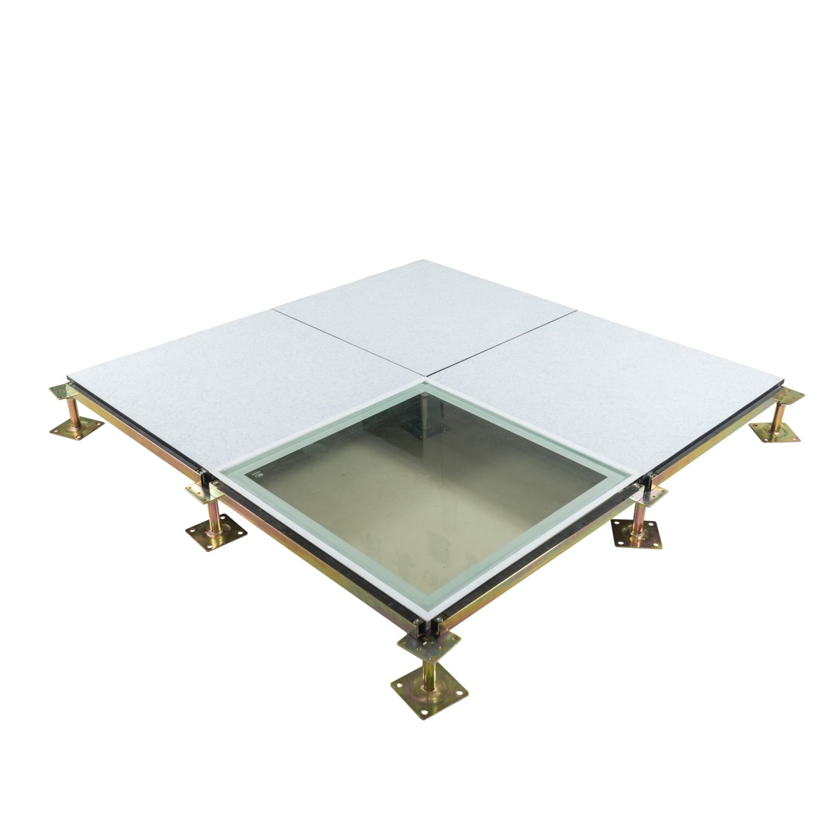
Beautiful, practical, generous, suitable for all kinds of computer room environment monitoring Indoor decoration Outdoor square landscape and other occasions. The anti-static transparent glass floor of the equipment room is used in all kinds of standard computer rooms, and the equipment, instruments, lines, and water leakage conditions
are checked 24 hours; The modern precision machine room needs to check the
running condition of the equipment at any time, and the conventional floor needs to
take off the original floor. It is very troublesome to use the high transparent anti-static glass floor. The glass floor has three requirements of high strength, beautiful and
practical, anti-static, and can be applied.

Finished Floor Height: | 70-2000mm
Panel Size: | 600*600mm、800*800mm and special size
Tempered Clear Glass: | 12、15、19mm
Tempered Laminated Glass: | 10+10mm、10+12mm、12+12mm

Tempered glass is a type of safety glass manufactured with the aid of heat or
chemicals used to strengthen the glass. This process is sometimes referred to as
“tempering.” Tempered glass can be up to four times stronger than typical annealed
glass of the same size and thickness.

Other benefits of tempered glass:
- More tensile strength (it can bend easier without breaking)
- Wind resistance
- If it breaks, tempered glass shatters into rounded cubes rather than pointy shards

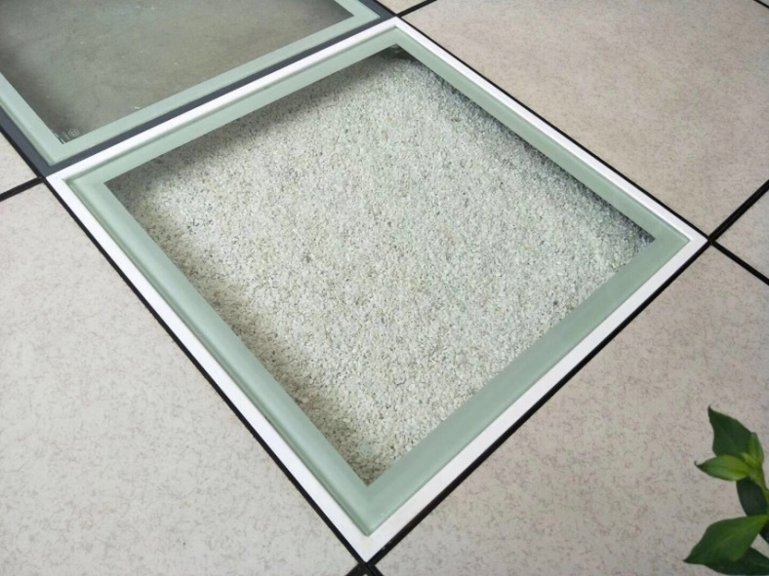
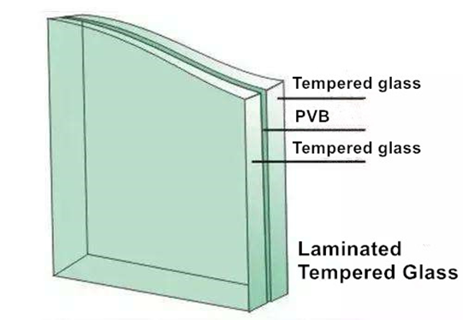

Laminated glass is a type of safety glass that is made of two or more panes of
annealed glass joined together by a layer of plastic, or polyvinyl butyral (PVB).
You can think of this joining as creating a glass sandwich (glass, plastic, glass).
Some types of laminated glass are made with multiple layers (think of these as a
laminated glass layer cake).

Laminated glass features:
- The plastic portion of laminated glass may be clear or tinted.
- Laminated glass aids in the screening of UV radiation.
- Laminated glass is beneficial for soundproofing.

One of the biggest benefits of laminated glass is that if it does break, the broken
glass will stick to the plastic rather than falling to the floor.

Applications:
Data Centers、Educational Facilities、Clean Rooms、Control Rooms、Libraries
and places where request continuous monitor of underfloor equipment or environment.

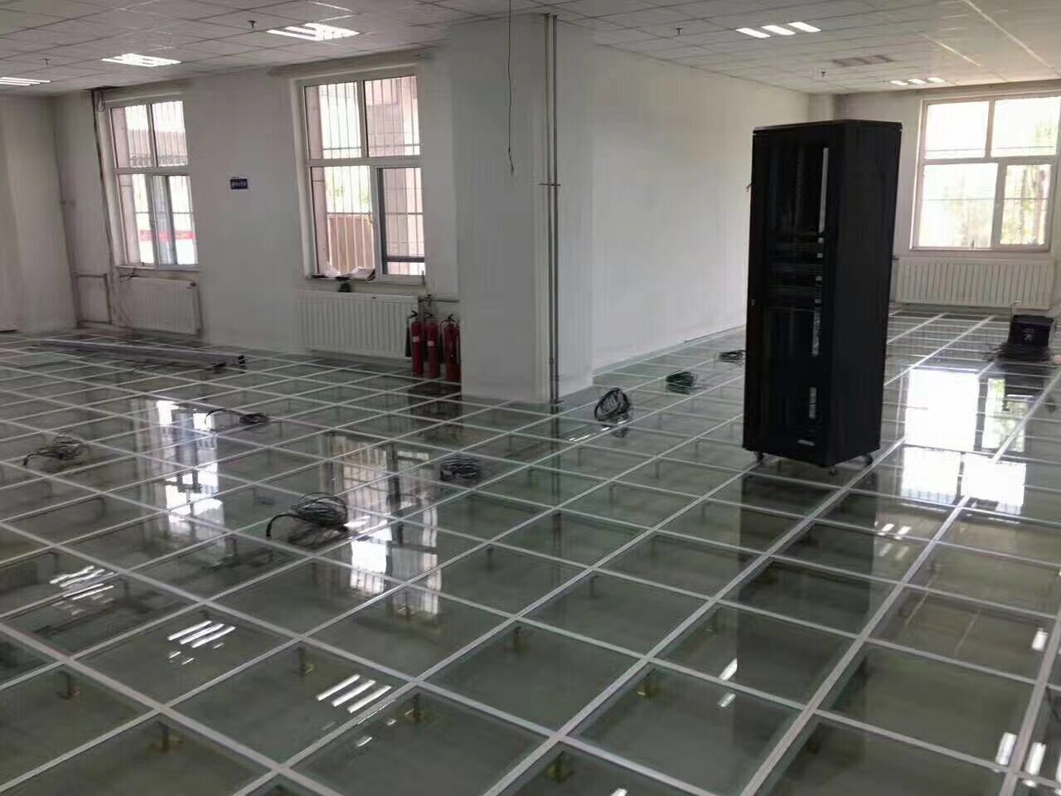

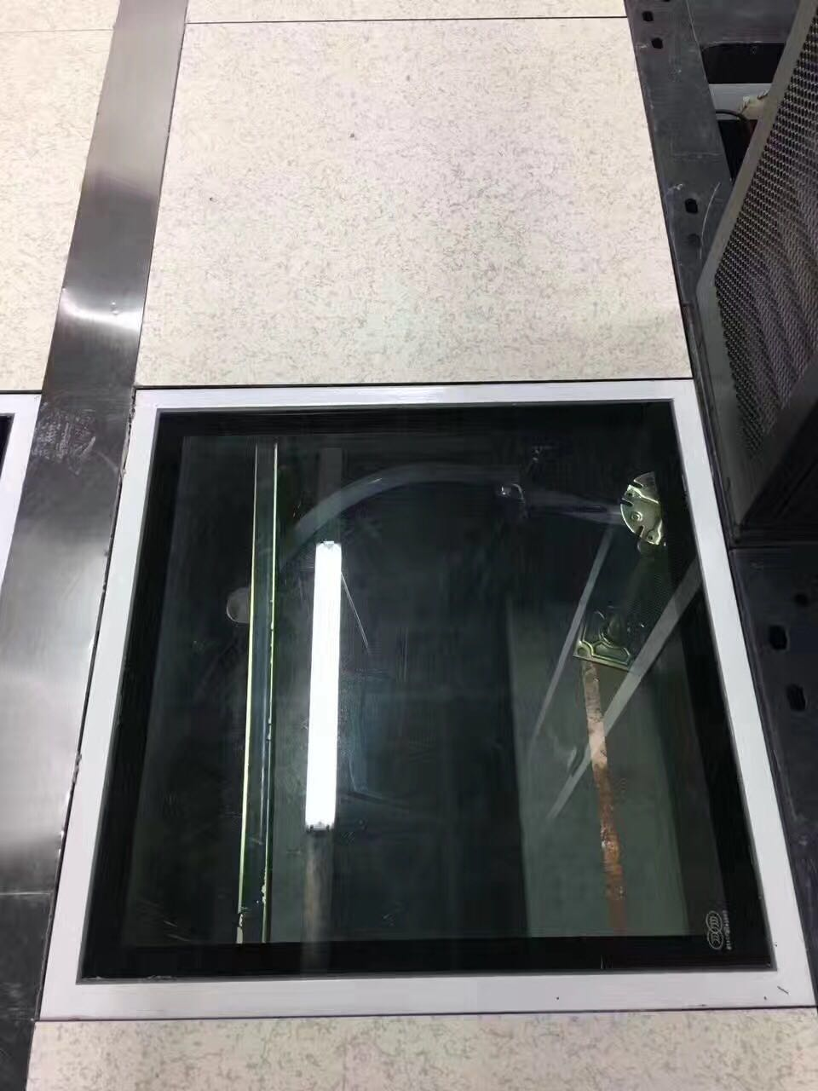
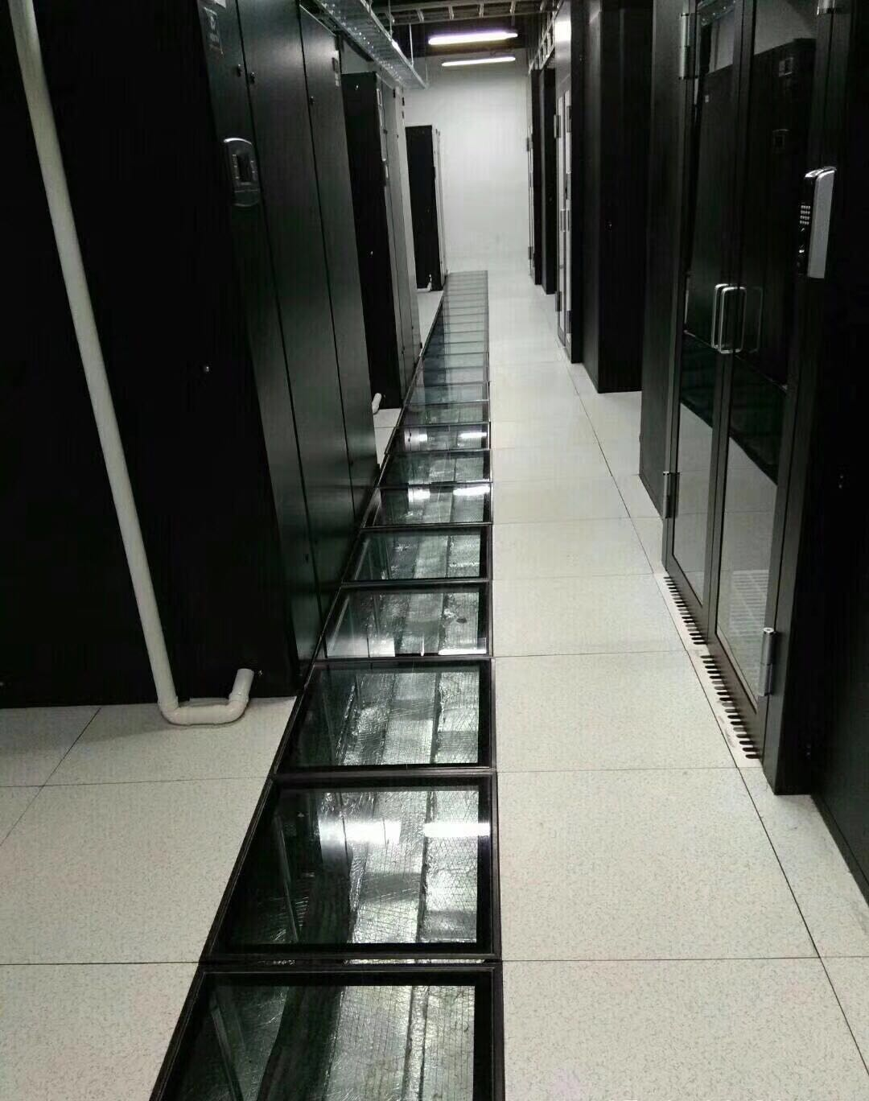

Changzhou Abeite Computer Room Equipment Co.,Ltd
Add: No. 108, Chaoyang Village, Hengshanqiao Town, Wujin District,
Changzhou City, Jiangsu Province，China
Tel: +86(519)86056270
Fax: +86(519)86056270
E-mail: gail@abeiteraisedfloor.com
Web: www. abeiteraisedfloor.com

