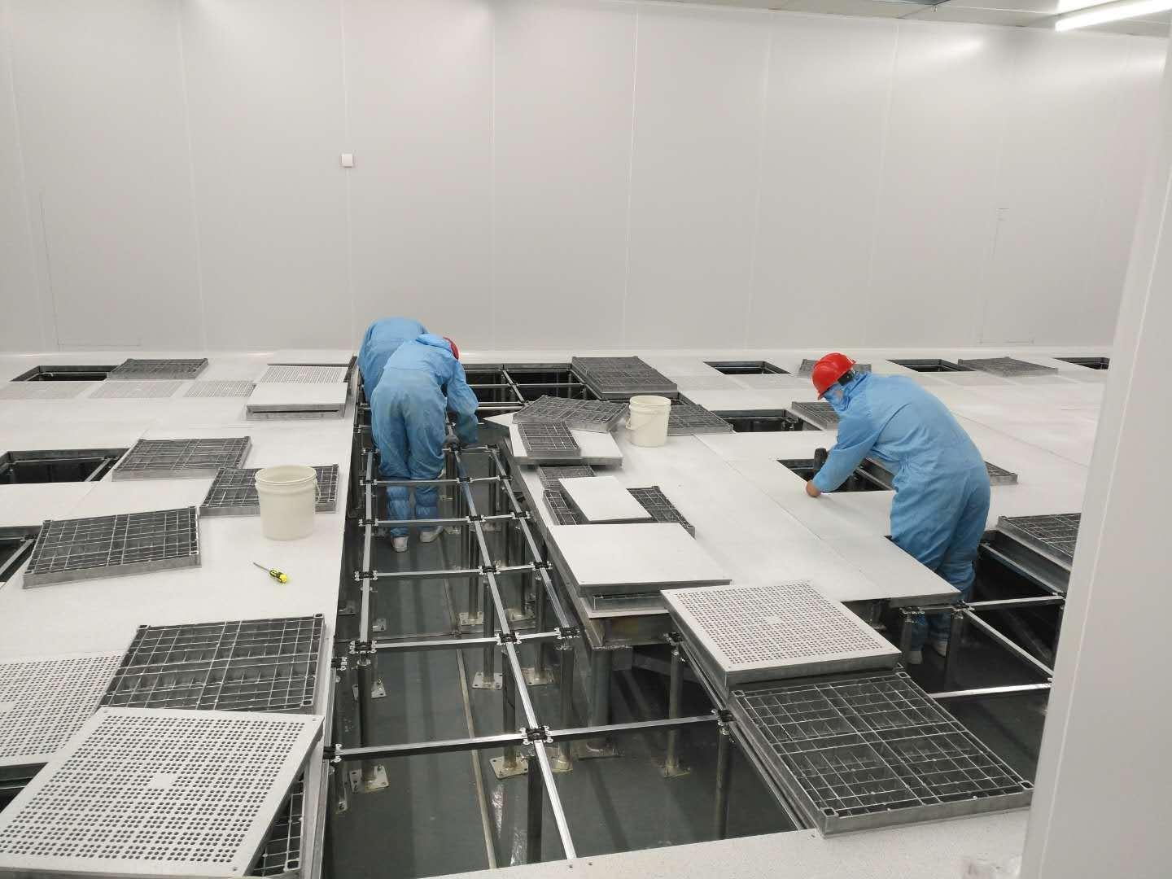

Aluminum Raised Floor

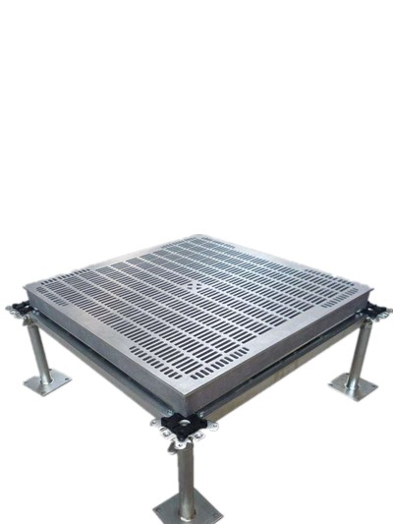
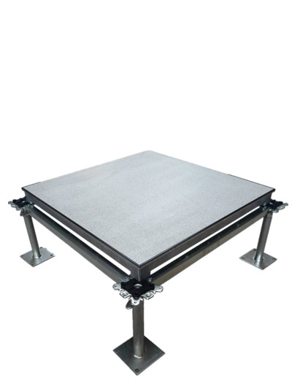
Abeite Aluminum Raised Floor made from precision machined die-cast aluminum,
specifically designed for the ultra-clean environment. The surface of the floor can be
epoxy powdered or nickel-cadmium plated according to the needs. The top finished
with HPL/PVC/Ceramic, etc covering, aluminum panel is available with corner locking
for vibration control.

Type: | FS662-2000
Finished Floor Height: | 100-2000mm
Panel Size: | 600*600mm
Panel Thickness: | Solid Panel / Perforated panel
Finish Covering: | 1.0-2.0mm Anti-static Laminate HPL、2.0-3.0mm PVC、10mm Cermic、Marble、Granite、Nature Wood and etc.
Edge trim: | Trimless / Nomal trim,
Corner lock hole | With / Without
Installation: | With Stringer System

Characteristics:
- 100% recyclable
- Novel structural design, high dimensional accuracy, not easy to deform
- Lightweight, high density, high strength, high load capacity
- Waterproof, fireproof, anti-corrosion, anti-magnetic, no pollution, no radiation
- Performance and its stability and never decline good static conductivity

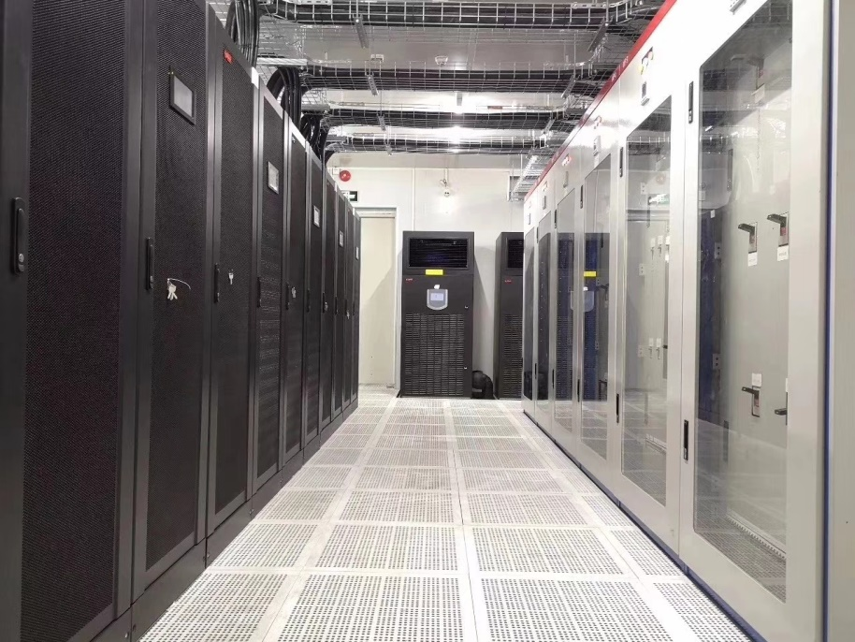
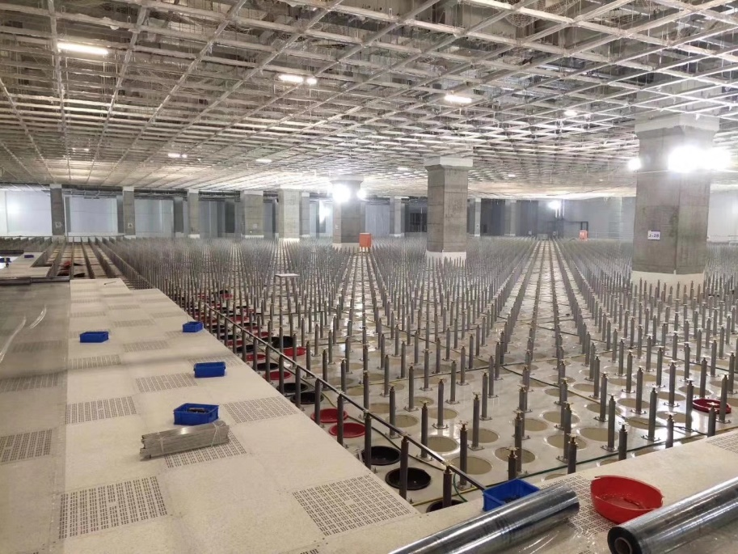

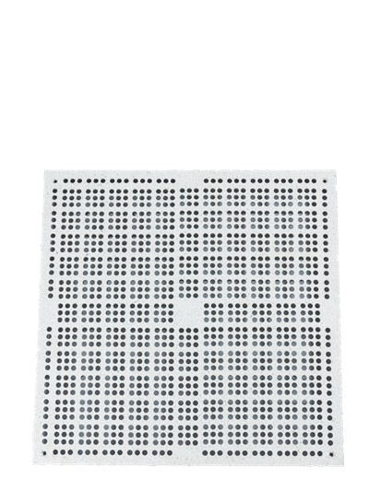
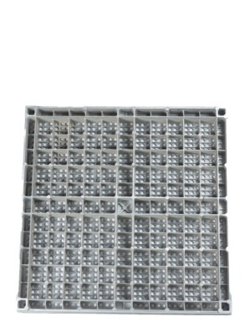
Applications:
Aluminum panel is mainly used for laying clean rooms with high requirements on air cleanliness, such as semiconductor production workshops,hospital laboratories, etc.

Ventilation Rate 15%

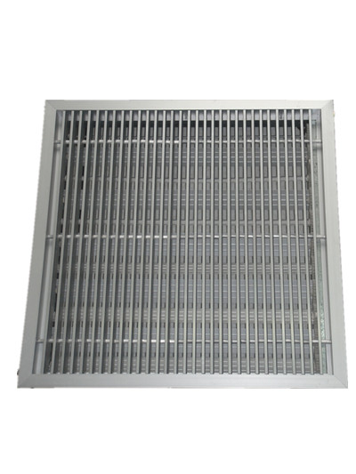

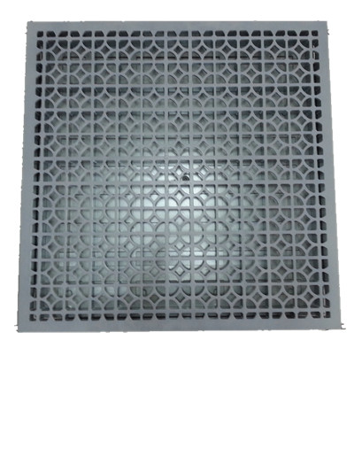

Ventilation Rate 60% Ventilation Rate 55%

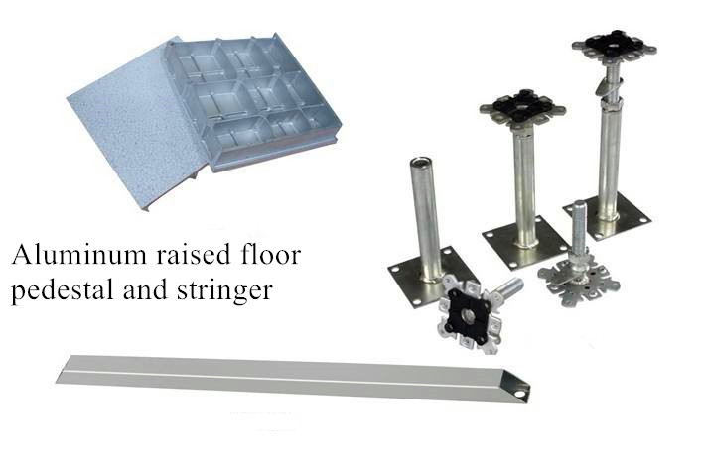

Changzhou Abeite Computer Room Equipment Co.,Ltd
Add: No. 108, Chaoyang Village, Hengshanqiao Town, Wujin District,
Changzhou City, Jiangsu Province，China
Tel: +86(519)86056270
Fax: +86(519)86056270
E-mail: info@abeiteraisedfloor.com
Web: www. abeiteraisedfloor.com

