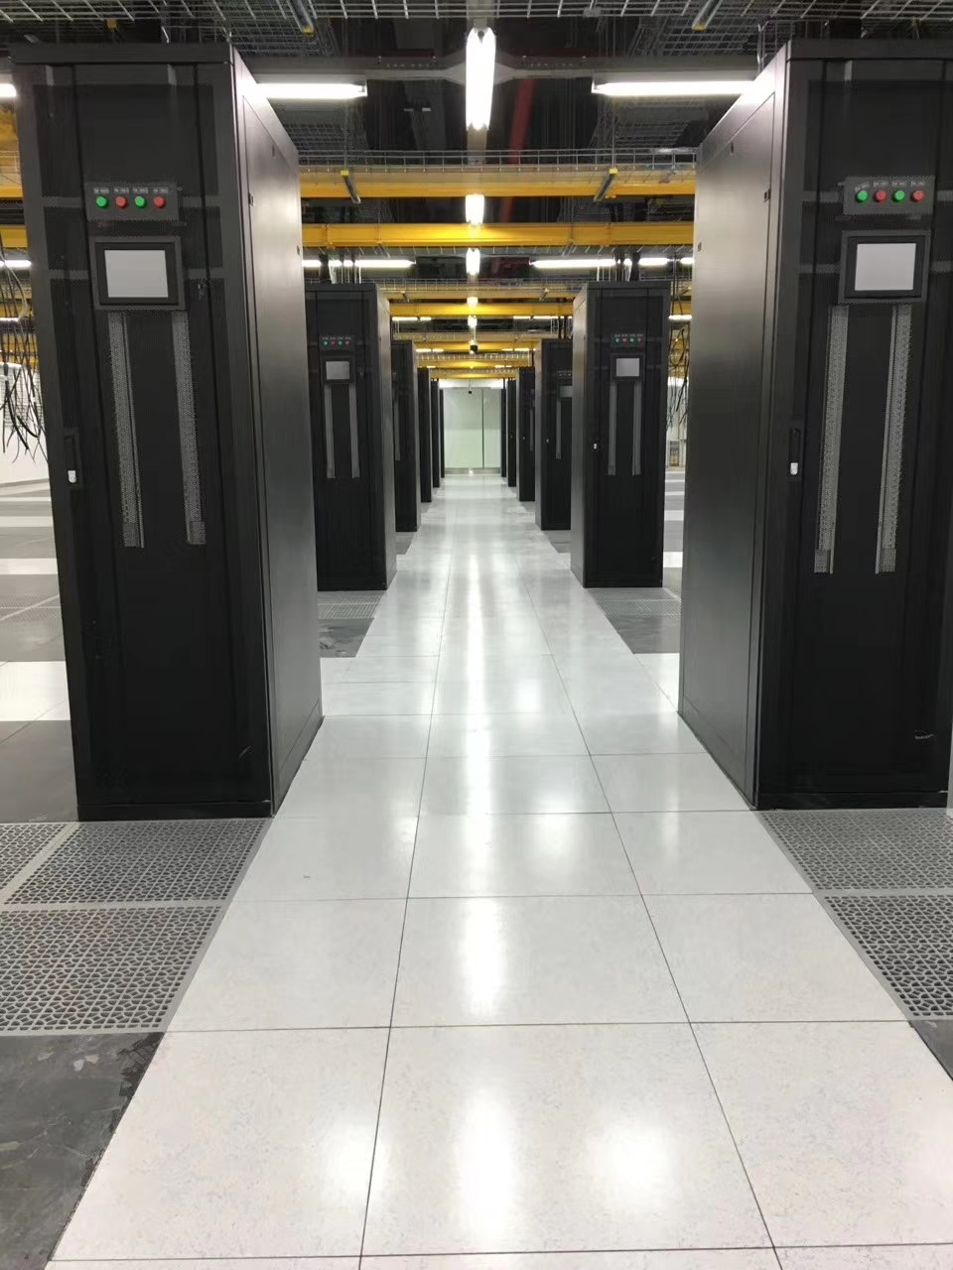

Aluminum Honeycomb Raised Floor

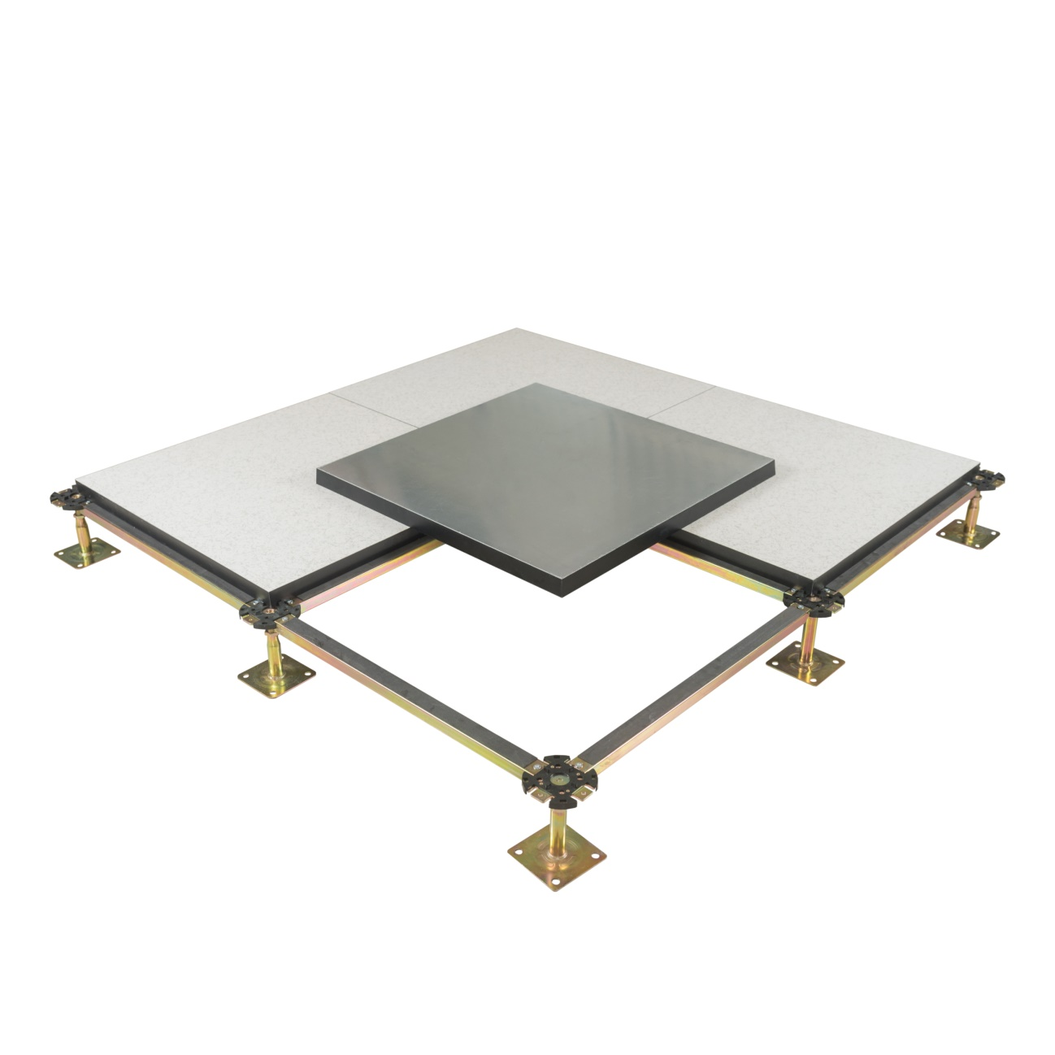

Abeite Aluminum Honeycomb Raised Floor is 100% recyclable. Lightweight
aluminum honeycomb as core panel, the top finished with HPL/PVC/Ceramic, etc
covering, galvanized steel sheet or aluminum foil to bottom, the four edges are wrapped
with conductive PVC trims.

Type: | FS662-2000
Finished Floor Height: | 100-2000mm
Panel Size: | 600*600mm
Panel Thickness: | 30/32/35/38/40mm
Finish Covering: | 1.0-2.0mm Anti-static Laminate HPL、2.0-3.0mm PVC、10mm Cermic、Marble、Granite、Nature Wood and etc.
Under Covering: | Bare、0.3-2.0mm Galvanized steel、0.1-2.0mm Aluminum Foil
Installation: | With Stringer System

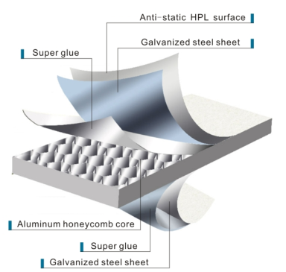
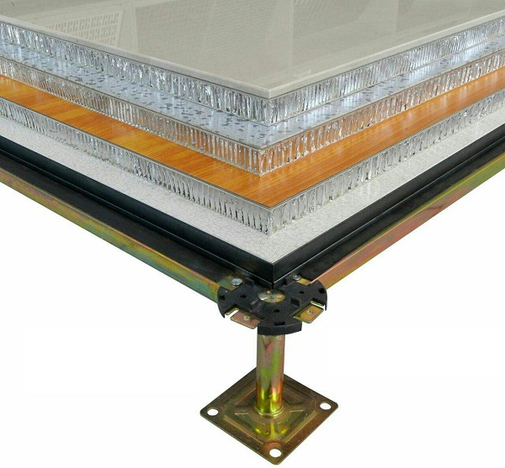

Characteristics:
- Non-combustible material;
- High dimensional precision: Tolerance of panel size is 0-0.40mm; Tolerance
of panel thickness is ±0.30mm; Un-flatness is ≤0.60mm;
- The load performance is strong, and the anti-static performance is excellent.
- Convenient removing, long performance life.
- Compared to other floors with the same advantages of a lightweight, like wood
core raised floor, Aluminum Honeycomb Floor’s capability of fire prevention and
anti-corrosive is superior.
- OEM is available;

Applications:
Data Centers、Commercial Buildings、Educational Facilities、Clean Rooms、
Control Rooms、Libraries and places where require anti-static environment
or have many wires.

Specification:

Type | Size | Concertrated Load Defleation≤2.5mm |  |  | Uniform Load | Ultimate Load | System Resistance
 | mm | LBS | KN | KG | KN/㎡ | KN | Ω
FS662 | 600*600 | 662 | 2.95 | 300 | 12.50 | 8.85 | 1.0x10⁶-1.0x10⁹
FS800 |  | 800 | 3.56 | 363 | 16.10 | 10.68
FS1000 |  | 1000 | 4.45 | 454 | 23.00 | 13.35
FS1250 |  | 1250 | 5.56 | 567 | 33.00 | 16.68
FS1500 |  | 1500 | 6.67 | 680 | 34.50 | 20.02
FS2000 |  | 2000 | 8.90 | 906 | 46.00 | 26.70

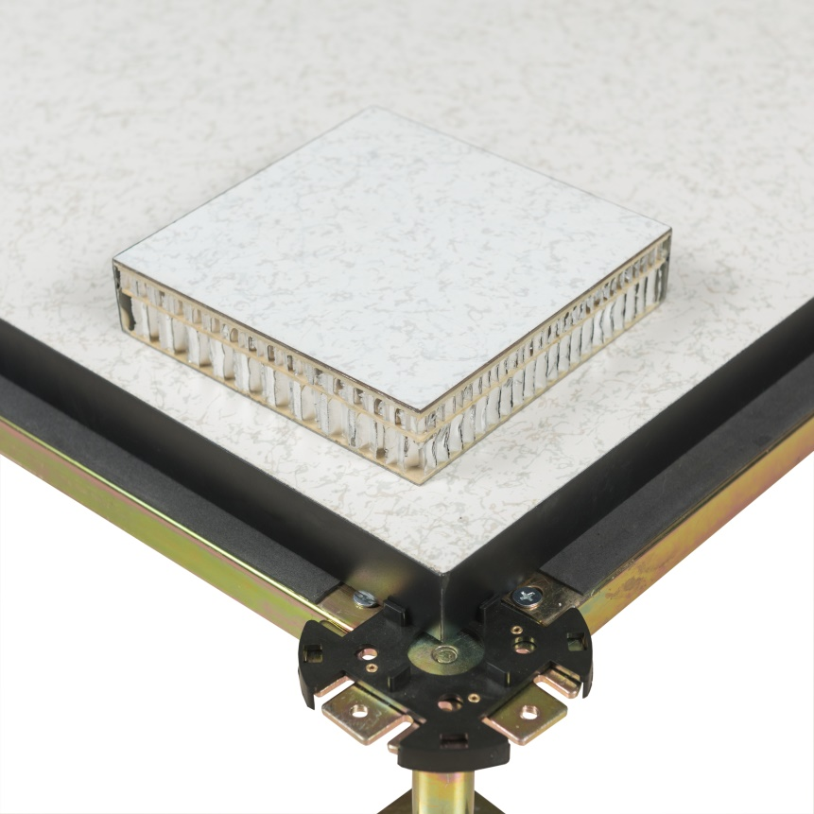

双层和单层的区别

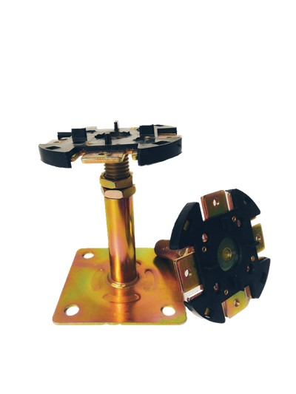

Understructures:
Product name: | Round Head Pedestal
Suggested Height: | FFH100-600mm
Tube: | Φ21*22*25*28/1.5mm
Top plate: | 90*90*3.0mm
Base plate:: | 95*95*2.0mm
Threaded rod: | M18/20/22
Threaded rod length: | 80mm/100mm and more
Surface: | Cold galvanizing Hot galvanizing Powder coated

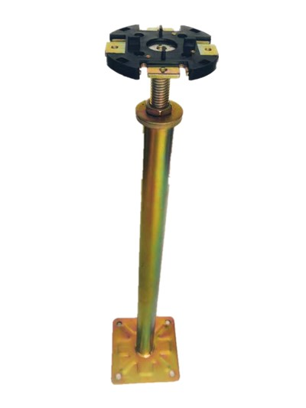
Product name: | Heavy duty pedestal
Suggested Height: | FFH600-2000mm
Tube: | Φ32/45/48*1.5mm
Top plate: | 90*90*3.0mm
Base plate:: | 95*95*3.0mm
Threaded rod: | M18
Threaded rod length: | 80mm/100mm and more
Surface: | Cold galvanizing Hot galvanizing Powder coated
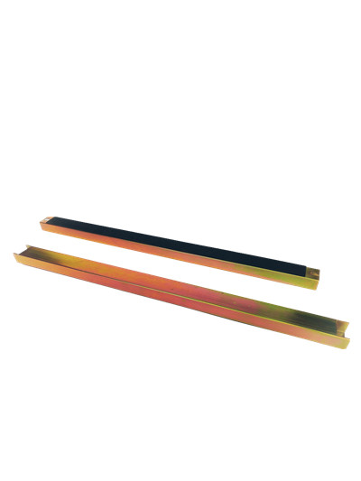

Product name: | Stringer
Size: | 540*31*22mm  1140*31*22mm
Steel thickness: | 1.0/1.2mm
Surface: | Cold galvanizing Hot galvanizing Powder coated
Gasket: | With

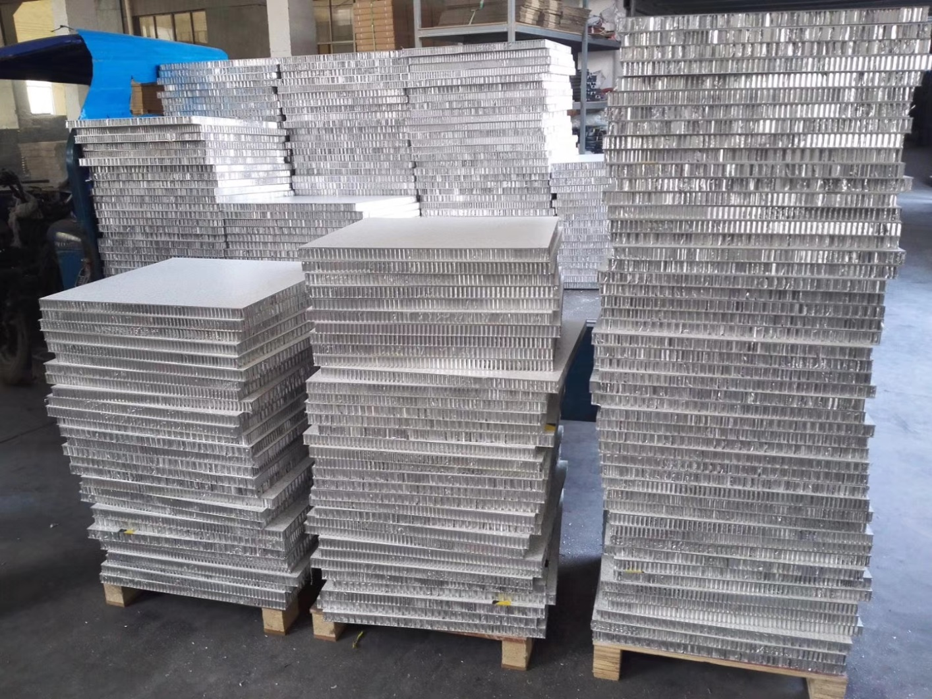

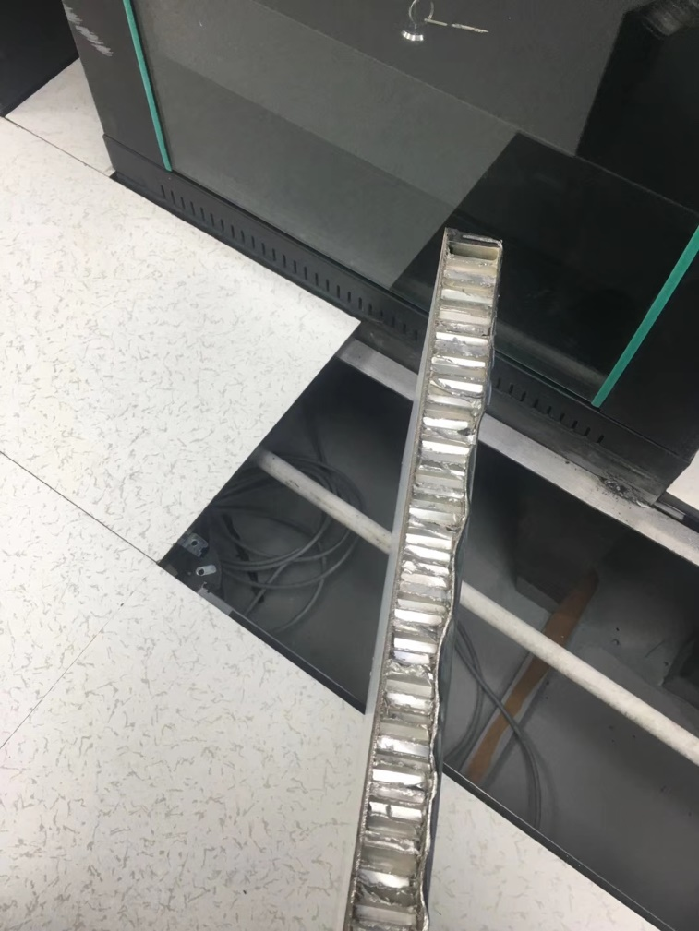

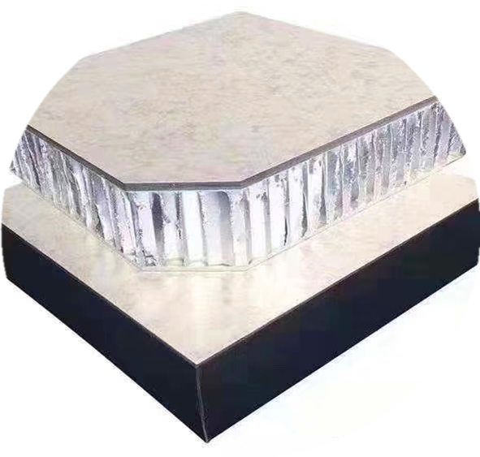

Changzhou Abeite Computer Room Equipment Co.,Ltd
Add: No. 108, Chaoyang Village, Hengshanqiao Town, Wujin District,
Changzhou City, Jiangsu Province，China
Tel: +86(519)86056270
Fax: +86(519)86056270
E-mail: info@abeiteraisedfloor.com
Web: www. abeiteraisedfloor.com

