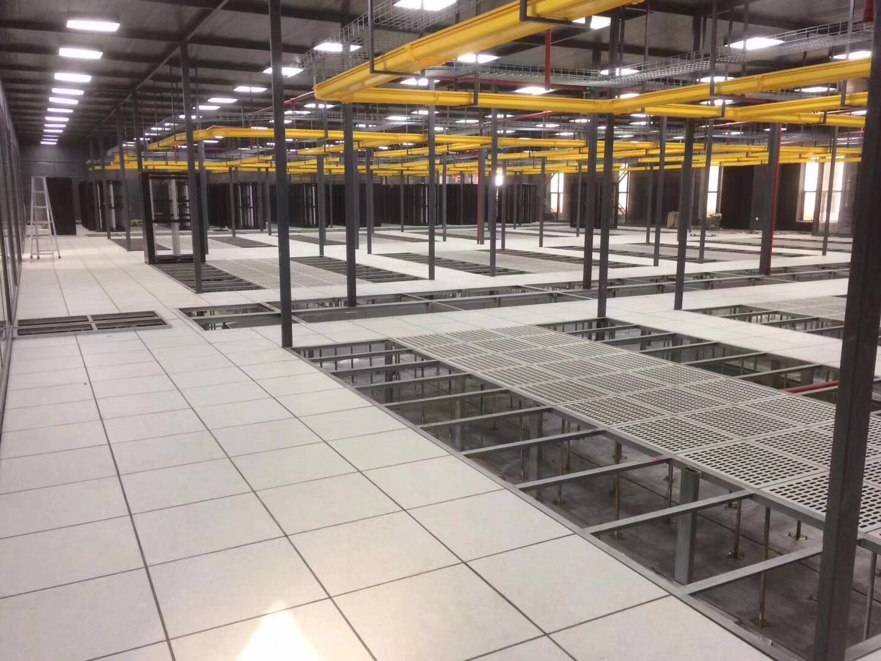

Anti-static Steel Raised Floor

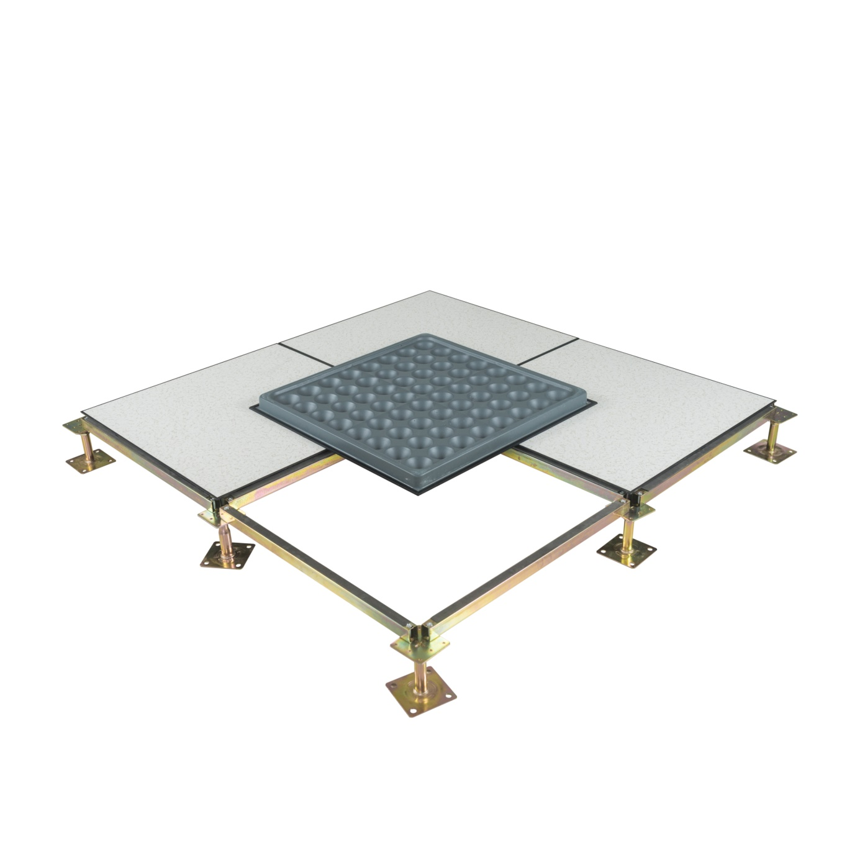

Abeite Anti-static Steel Raised Floor is a new patent “cross strengthening rib”
and “concave rib structure”, which can enhance 10-30% more loading capacity.
From the selection of materials, procurement, production, packaging, are compliant
with the Chinese and PSA MOB PS/SPU、DIN EN 12825 specifications.

Construction:
Anti-static Steel Raised Floor is manufactured from cold-rolled steel resistance
welded, lightweight cement infilled. The top finished with HPL/PVC, etc covering,
the borders are trimmed with conductive rubber edges. The raised floor system
is composed of panels, adjustable height of pedestals, stringer, and screws.
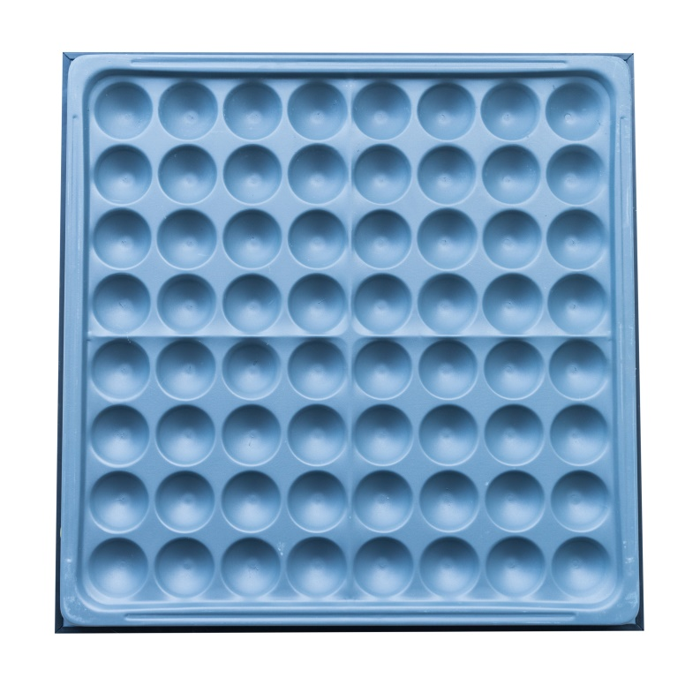
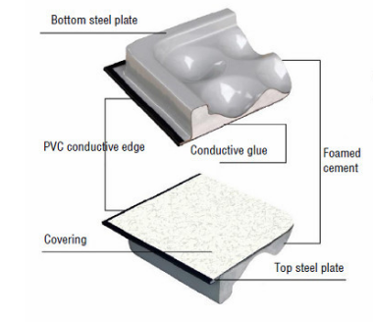

Type: | FS662-1500
Finished Floor Height: | 100-1000mm
Panel Size: | 600*600*33mm、610*610mm(24″*24″)
Edge trim type: | Formal trim、Trimless、 ”F”edge trim、Printed trim
Finish Covering: | 1.0-2.0mm Anti-static Laminate HPL、2.0-3.0mm PVC、10mm Cermic、Marble、Granite、Nature Wood and etc.
Installation: | With Stringer System

Formal trim Trimless

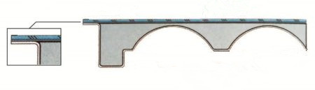

”F”edge trim Printed trim

Characteristics:
- Epoxy paint for lifetime protection;
- Tolerance of panel size is 0-0.40mm; Tolerance of panel thickness is ±0.30mm;
Un-flatness is ≤0.60mm;
- The load performance is strong, and the anti-static performance is excellent.
- Class A flame spread & smoke-developed index
- OEM is available;

Applications:
Data Centers、Commercial Buildings、Educational Facilities、Clean Rooms、Control
Rooms、Libraries and places where require anti-static environment or have many wires.

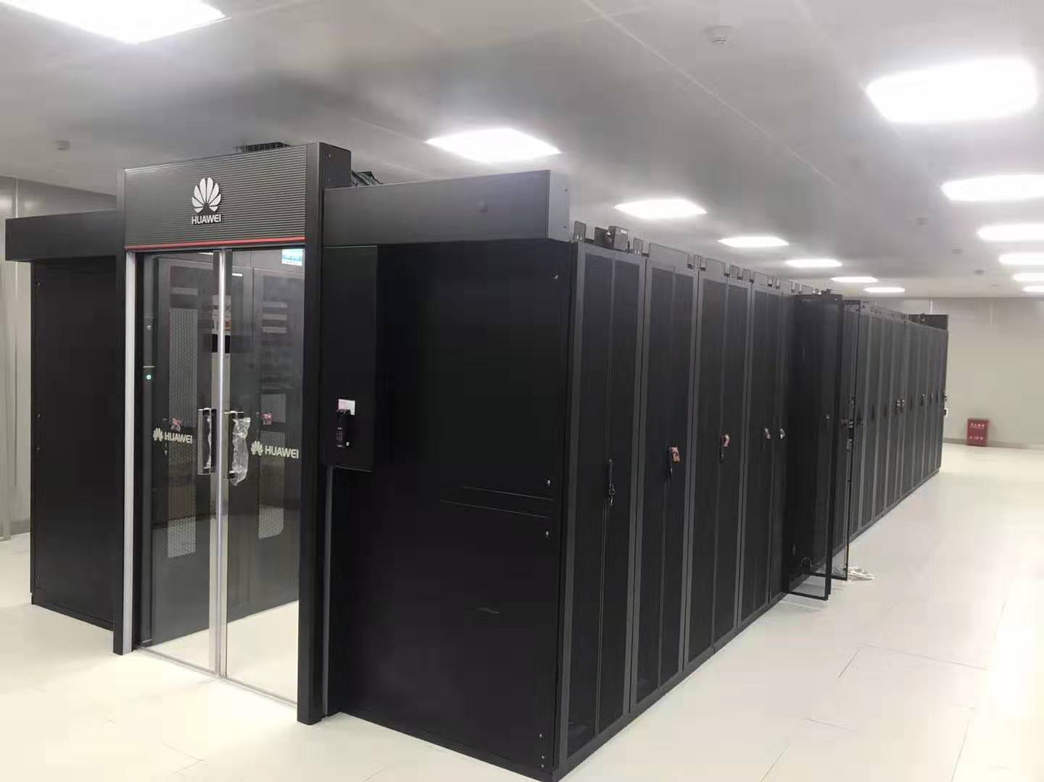
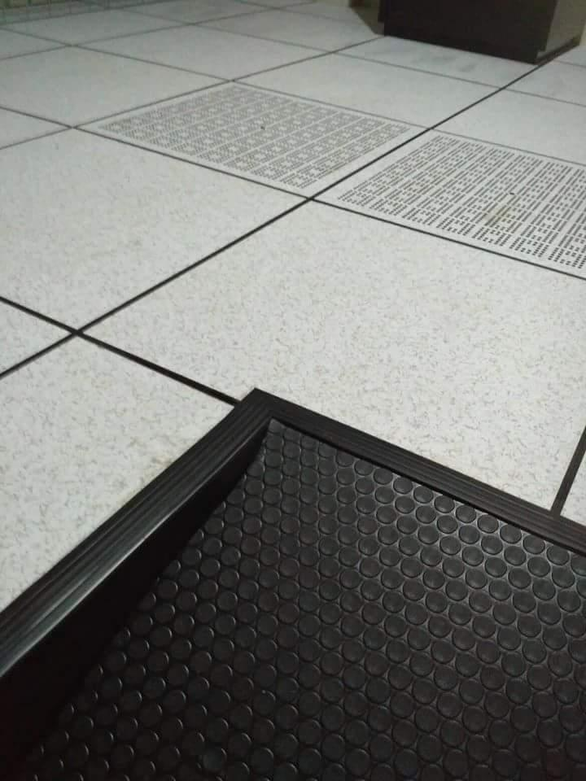

Specification:

Type | Size | Concertrated Load Defleation≤2.5mm |  |  | Uniform Load | Ultimate Load | System Resistance
 | mm | LBS | KN | KG | KN/㎡ | KN | Ω
FS662 | 600*600 (610*610 is optional) | 662 | 2.95 | 300 | 12.50 | 8.85 | 1.0x10⁶-1.0x10⁹
FS800 |  | 800 | 3.56 | 363 | 16.10 | 10.68
FS1000 |  | 1000 | 4.45 | 454 | 23.00 | 13.35
FS1250 |  | 1250 | 5.56 | 567 | 33.00 | 16.68
FS1500 |  | 1500 | 6.67 | 680 | 34.50 | 20.02
FS2000 |  | 2000 | 8.90 | 906 | 46.00 | 26.70

Understructures:
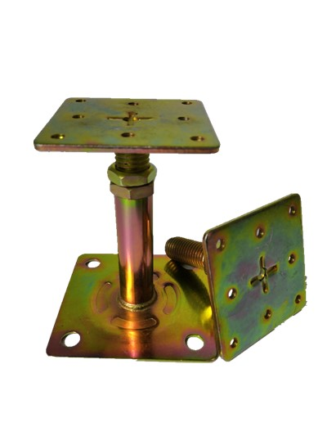
Product name: | Flat Head pedestal
Suggested Height: | FFH50-600mm
Top plate: | 75*75*3.0mm
Base plate:: | 95*95*2.0mm
Tube: | Φ21*1.5mm
Threaded rod: | M18/20/22
Threaded rod length: | 80mm/100mm and more
Surface: | Cold galvanizing  Hot galvanizing  Powder coated
Gasket: | With or Without

Product name: | Heavy duty pedestal
Suggested Height: | FFH600-2000mm
Top plate: | 75*75*3.0mm
Base plate:: | 125*125*3.0mm
Tube: | Φ32/45/48*1.5mm
Threaded rod: | M18
Surface: | Cold galvanizing  Hot galvanizing  Powder coated
Gasket: | With or Without

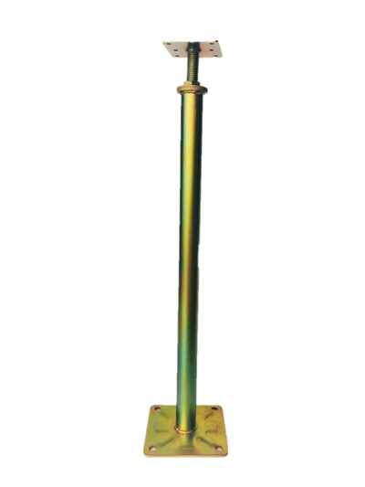

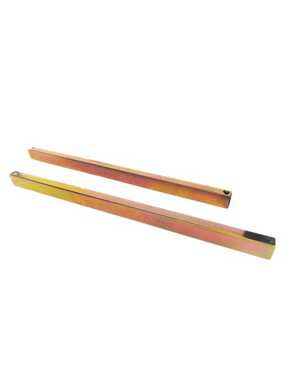

Product name: | Stringer
Size: | 570*32*21mm  1170*32*21mm
Steel thickness: | 1.0mm/1.2mm
Surface: | Cold galvanizing  Hot galvanizing  Powder coated
Gasket: | With or Without

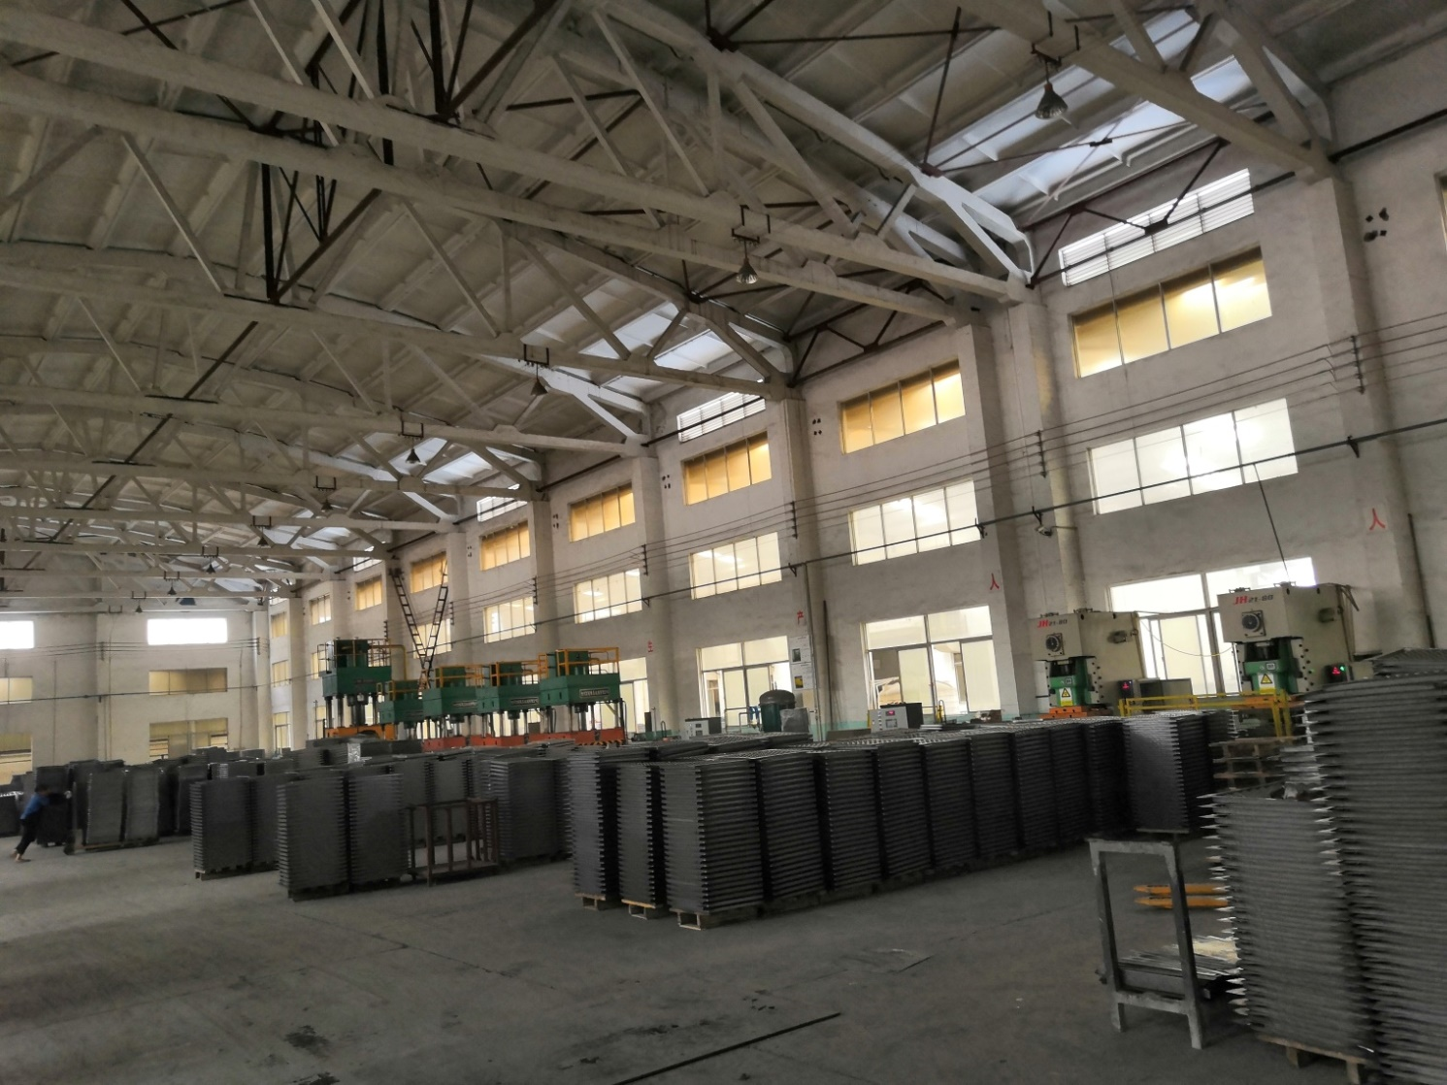

Changzhou Abeite Computer Room Equipment Co.,Ltd
Add: No. 108, Chaoyang Village, Hengshanqiao Town, Wujin District,
Changzhou City, Jiangsu Province，China
Tel: +86(519)86056270
Fax: +86(519)86056270
E-mail: info@abeiteraisedfloor.com
Web: www.abeiteraisedfloor.com

