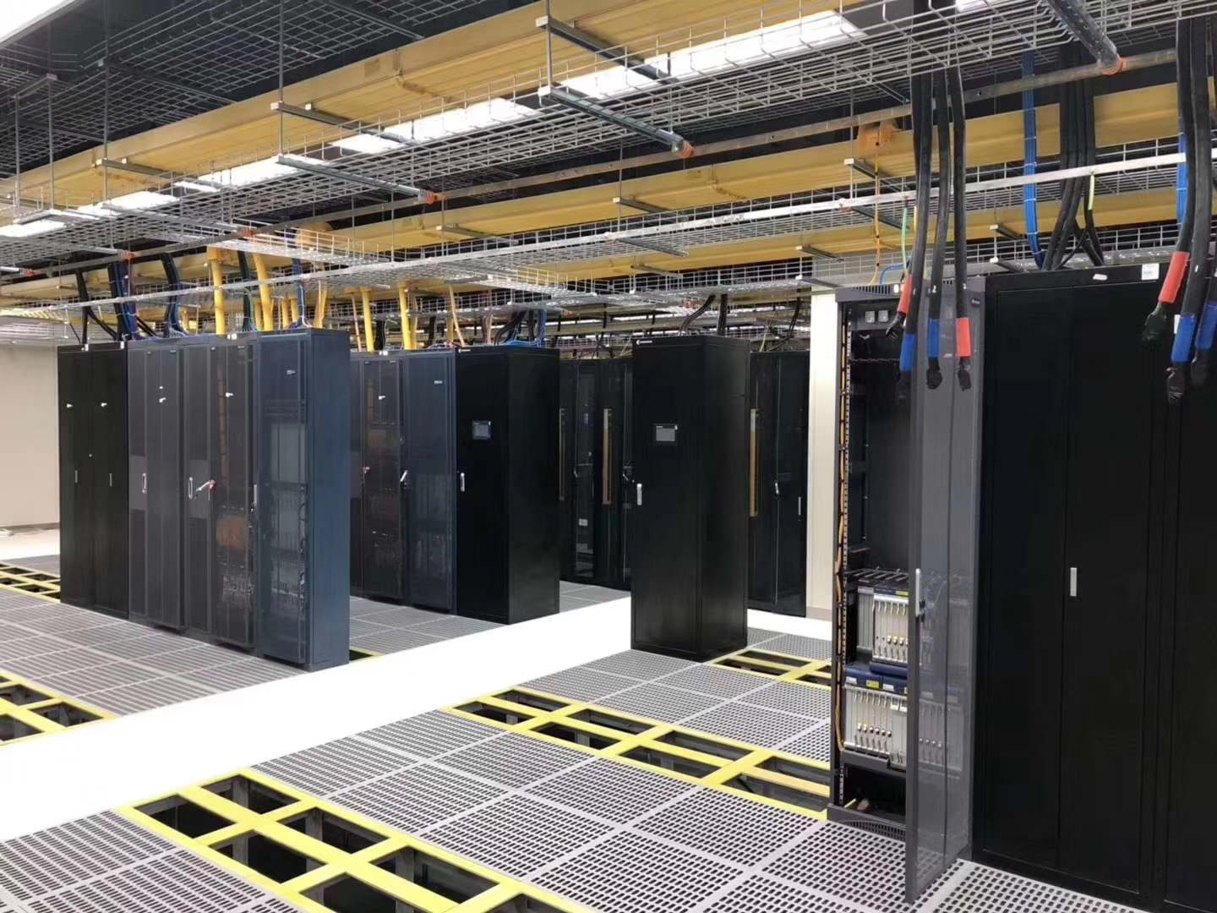

Airflow Perforated Raised Floor

Abeite Airflow Perforated Raised Floor could in combination with steel raised
floor, calcium sulfate raised floor, wood core raised floor and aluminum raised floor.
Airflow perforated panel could cater to all your data center cooling needs, It use
the underfloor plenum for air supply or return and it takes advantage of natural thermal
lift with warm and stale air extracted by ceiling returns. This results in more pleasant
working conditions for human comfort. It is available in standard or heavy-duty load
ratings and surface coverings finish are tailored to match the finish of the solid panel.

Ventilation Rate: | 15%-65%
Materials: | Steel、Aluminum
Panel Size: | 600*600mm and other special size
Edge Trim Type: | Formal trim、Trimless
Finish Covering: | Bare with powder coated、1.0-2.0mm Anti-static Laminate HPL、2.0-3.0mm PVC、10mm Cermic and etc.
Damper: | Available
Installation: | With Stringer System

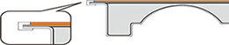

Formal trim Trimless

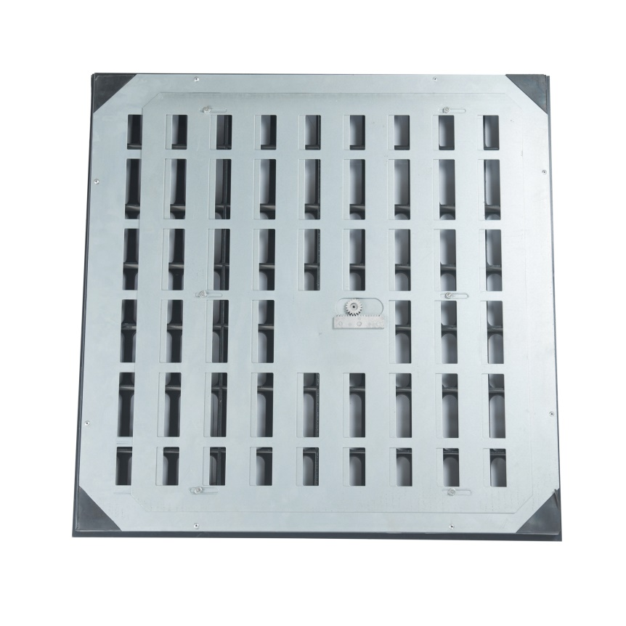
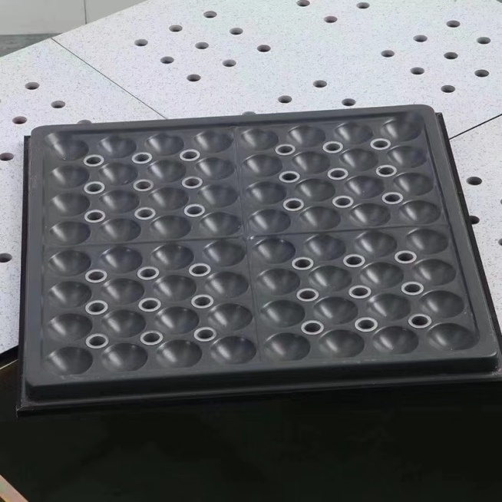

Damper Ceramic finish airflow panel

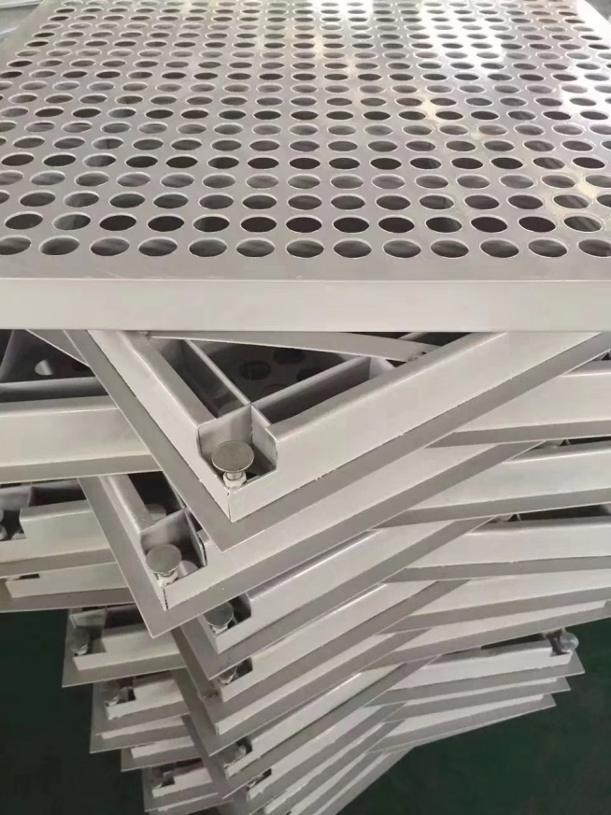
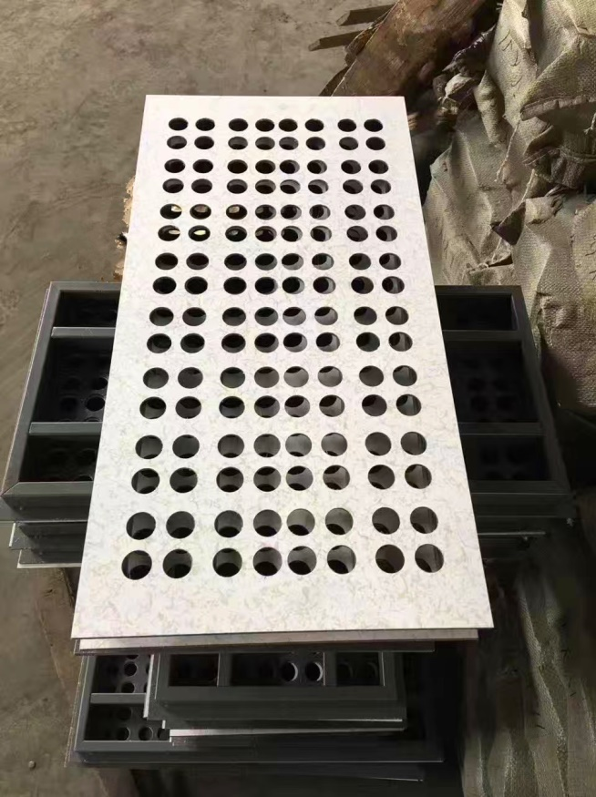

Special size airflow panel Adjustable height

Steel airflow panel
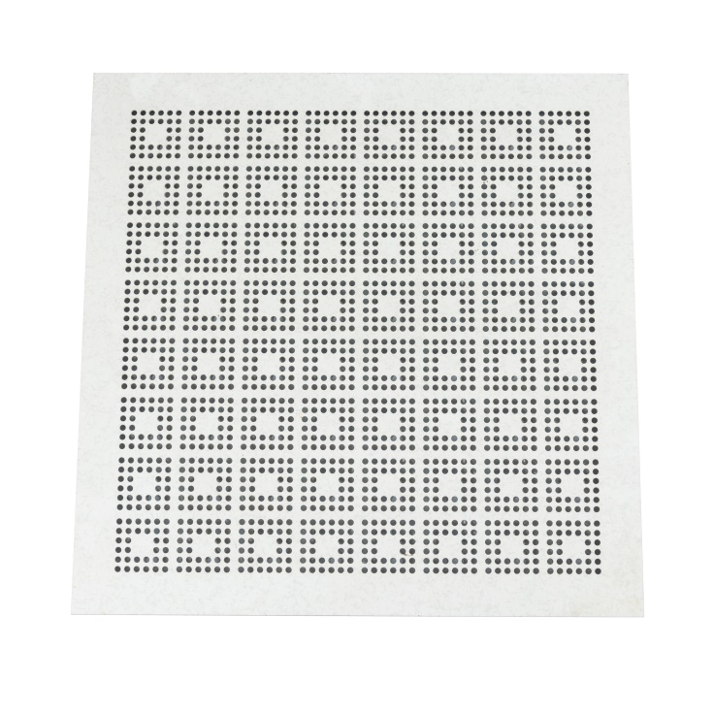
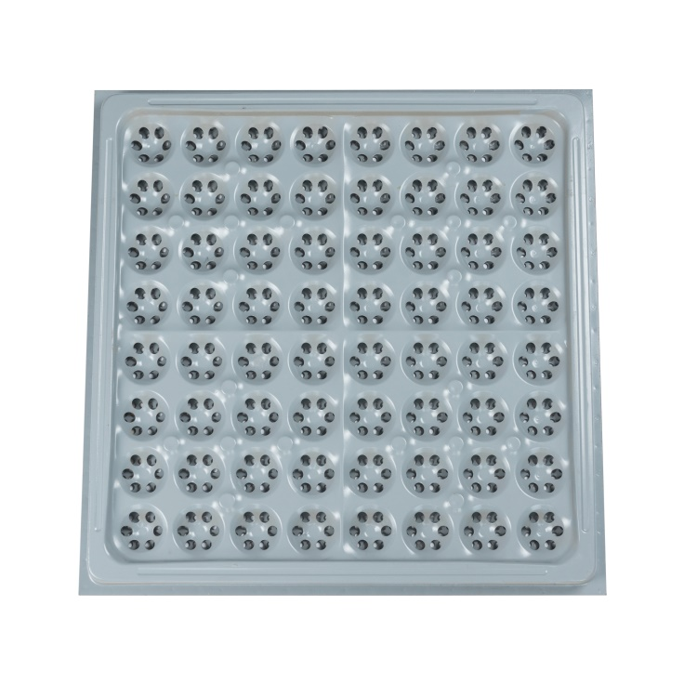

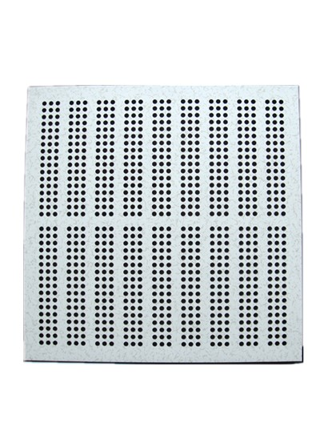
Ventilation Rate 15%
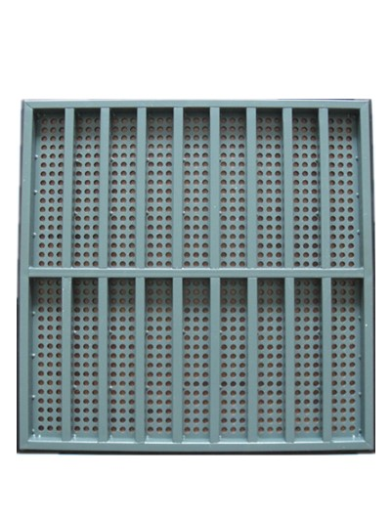
φ8mm * 2048 pcs airflow hole

Ventilation Rate 20%
φ10mm * 918 pcs airflow hole

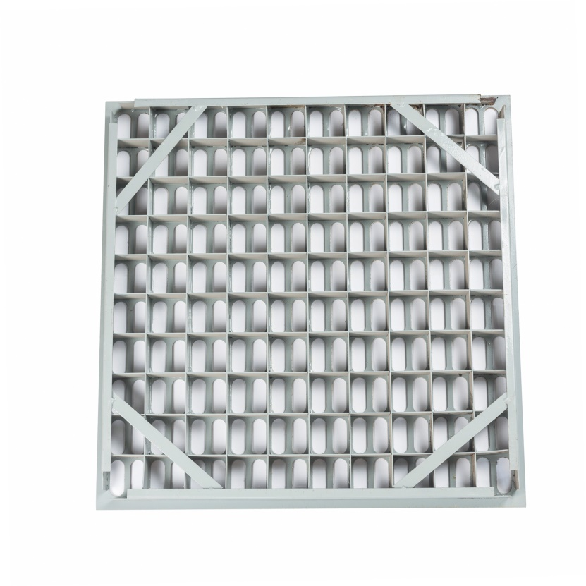
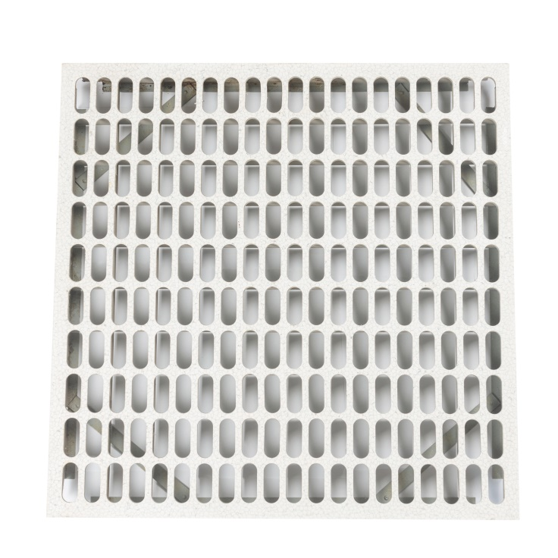

Ventilation Rate 50%
200pcs airflow hole

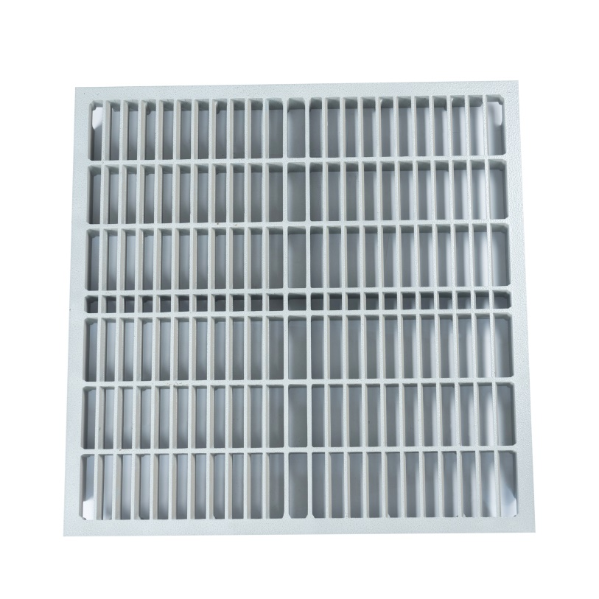
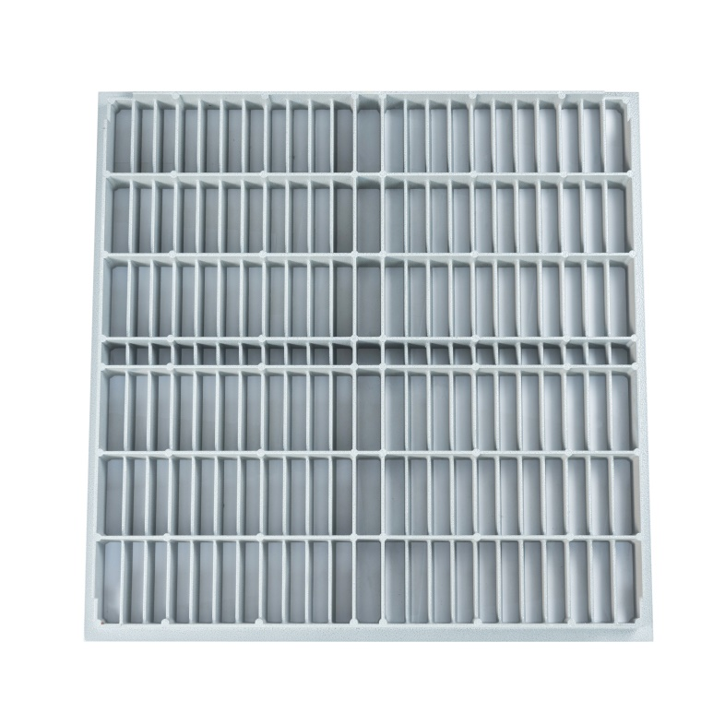

Ventilation Rate 65%

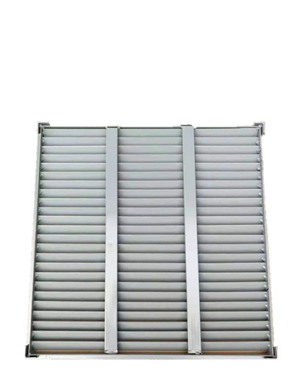
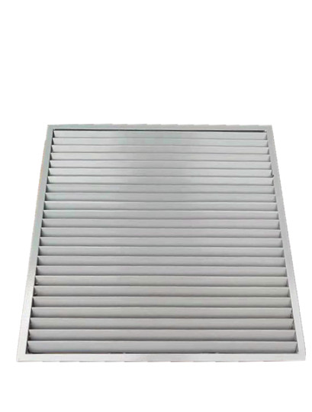

Ventilation Rate 70%

Aluminum airflow panel
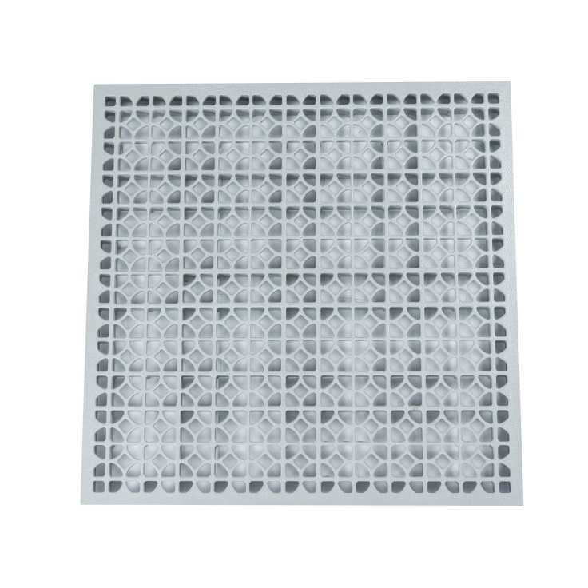
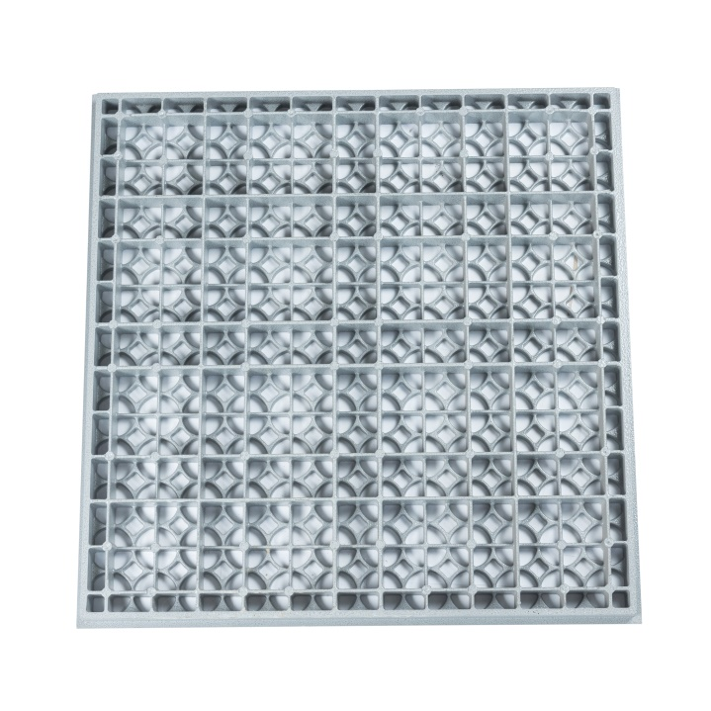

Ventilation Rate 55%

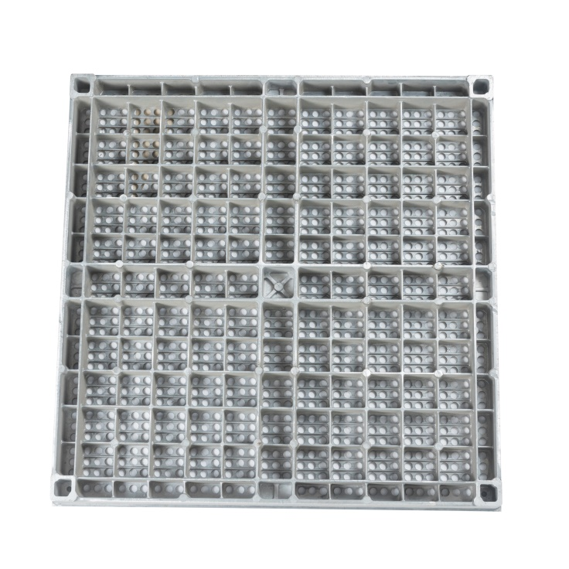
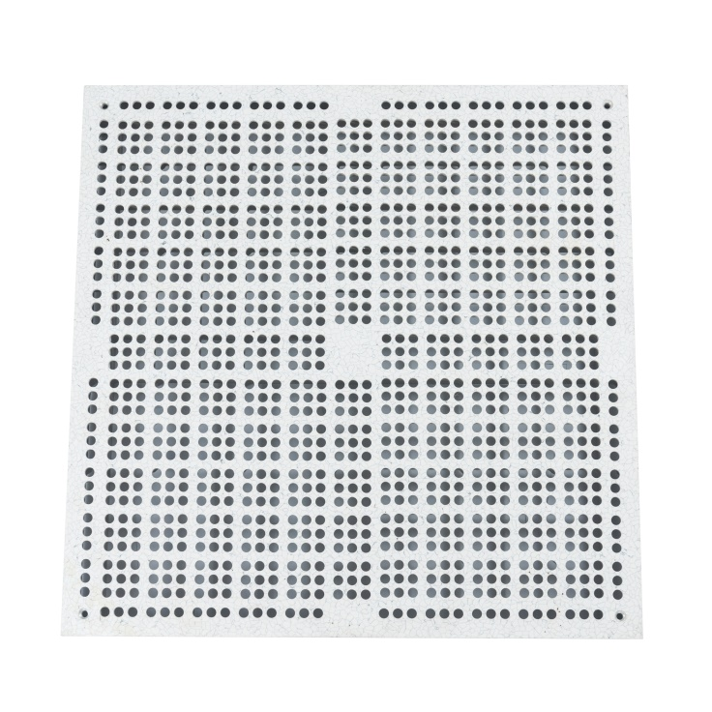

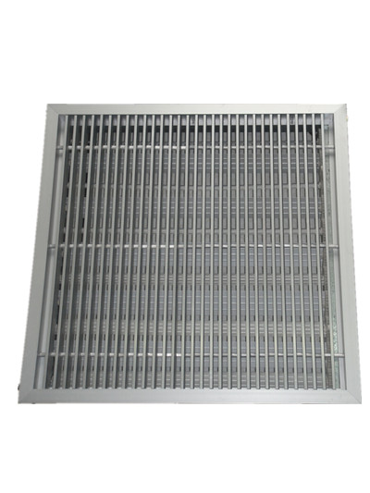
Ventilation Rate 15%

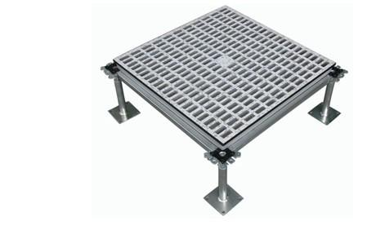

Ventilation Rate 35% Ventilation Rate 60%

Applications:
All kinds of the computer room, communication room, monitoring and command
center, electronic factory clean room, switch room and other pipelines where air
circulation requirements are relatively concentrated and dustproof and anti-static.

Changzhou Abeite Computer Room Equipment Co.,Ltd
Add: No. 108, Chaoyang Village, Hengshanqiao Town, Wujin District,
Changzhou City, Jiangsu Province，China
Tel: +86(519)86056270
Fax: +86(519)86056270
E-mail: info@abeiteraisedfloor.com
Web: www. abeiteraisedfloor.com

